# AWS Notes:

## What is cloud computing?

Cloud computing is like renting a computer, software, or storage space over the internet instead of owning and maintaining your own physical hardware. It allows you to access and use computing resources on-demand, paying only for what you use, and all the heavy lifting (like storing data or running applications) happens on servers in remote data centers rather than on your local device. It's a flexible and cost-effective way to handle digital tasks without the need for large upfront investments in hardware.

* On Premise:

1. You own the servers.
2. You hire the IT People
3. You Pay or Rent the real estate.
4. You take all the risks.

* Cloud Providers:

1. Someone else owns the servers.
2. Someone else hires the IT People
3. Someone else pays or rents the real estate.
4. You are responsible for your configuration cloud services and code, someone else takes care of the rest.

## The evolution of Cloud Hosting:

1. Dedicated Servers:

* One physical server dedicated to a single business.
* Runs a single web app/site.
* Very expensive, High Maintenance, High Security.

1. Virtual Private Server:

* One Physical machine dedicated to single business.
* The one physical machine is virtualized into submachines to run multiple web apps/sites.
* Better Utilization and isolation of resource

1. Shared Hosting:

* One Physical machine, shared by hundreds of businesses.
* Relies on most tenants underutilizing their resources.
* Very cheap, Limited functionality, Poor Isolation.

1. Cloud Hosting:

* Multiple physical machines that act as one system.
* The system is abstracted into multiple cloud services.
* Flexible, Scalable, Secure, Cost effective, High Configurability

Cloud hosting is a type of web hosting service that utilizes the resources of multiple interconnected servers to provide scalable and flexible computing power. Instead of relying on a single physical server, cloud hosting uses a network of virtual servers hosted on a distributed infrastructure, often referred to as a cloud. This allows users to easily scale their resources up or down based on demand. Cloud hosting offers advantages such as high availability, reliability, and redundancy, as well as the ability to pay for resources on a pay-as-you-go basis. It is suitable for a wide range of applications, from websites to complex business solutions, providing efficient and cost-effective hosting solutions.

## What are Amazon Web Services?

AWS is a cloud computing platform by Amazon that provides a variety of on-demand computing services, enabling users to scale their digital infrastructure easily and flexibly without the need for physical hardware ownership or management.

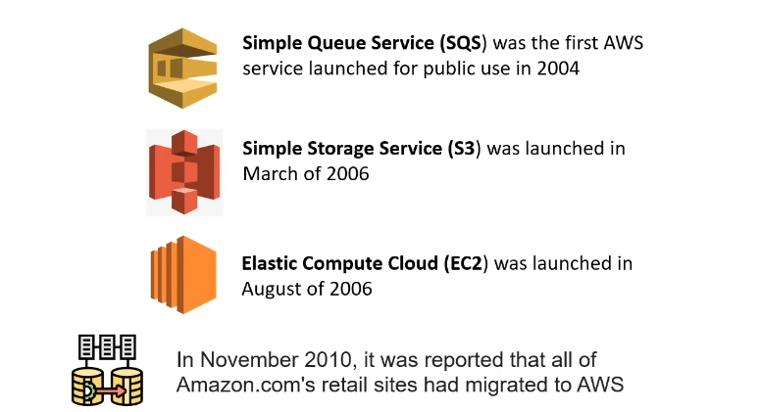

## What is a cloud service provider?

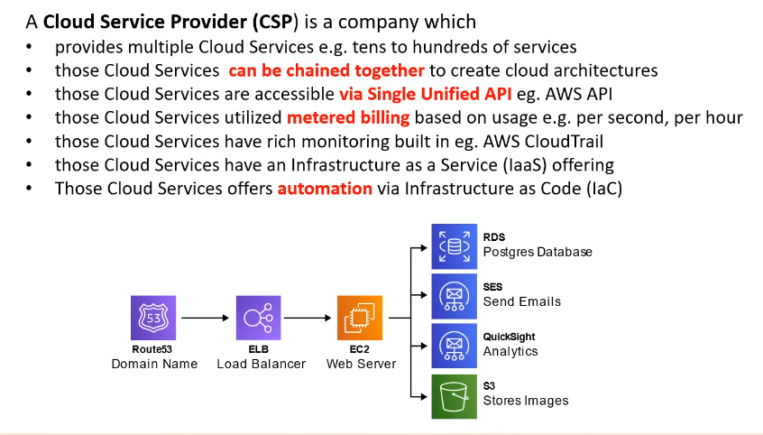

## Landscape of CSP’s:

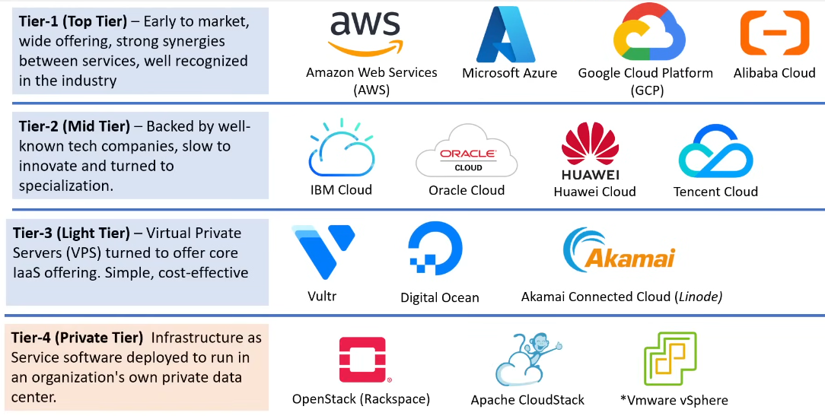

## Common Cloud Services:

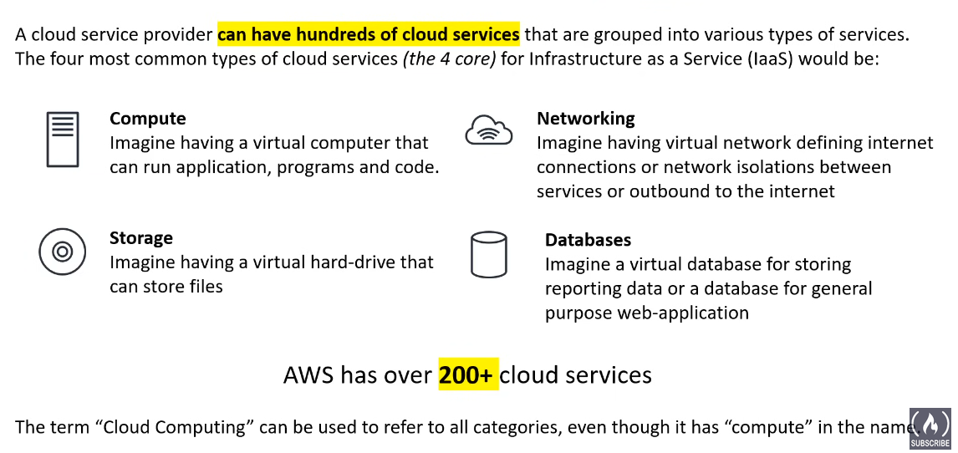

## Technology Overview:

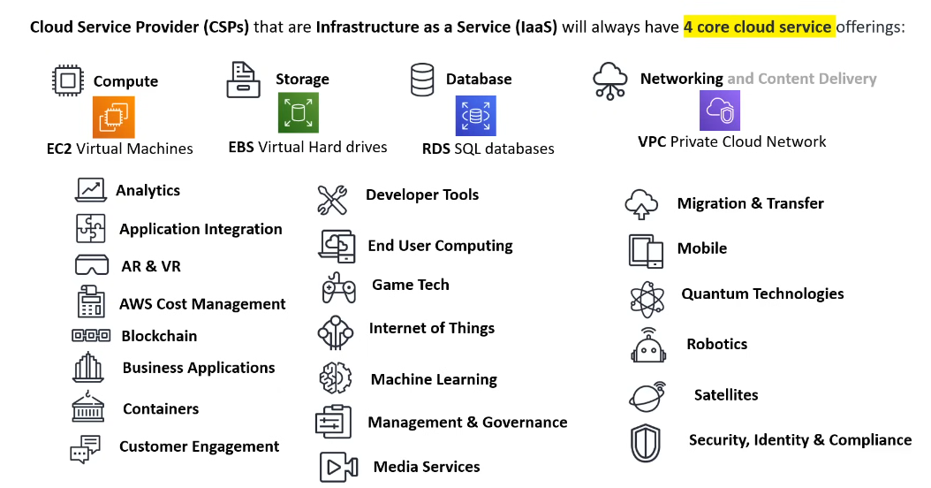

## The Evolution of computing:

1. Dedicated Servers:

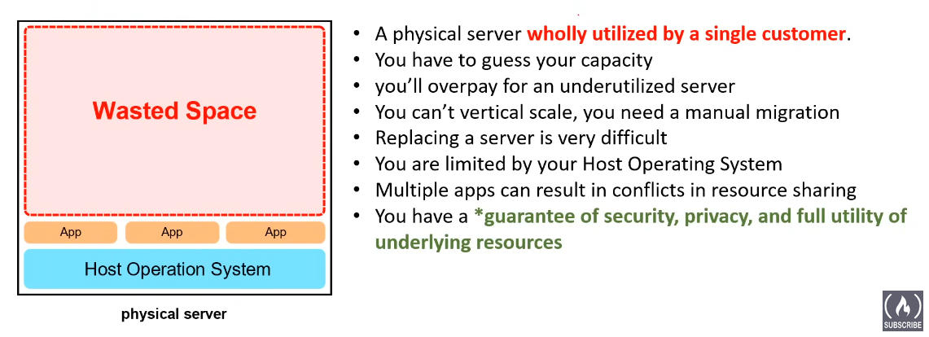

1. Virtual Machines:

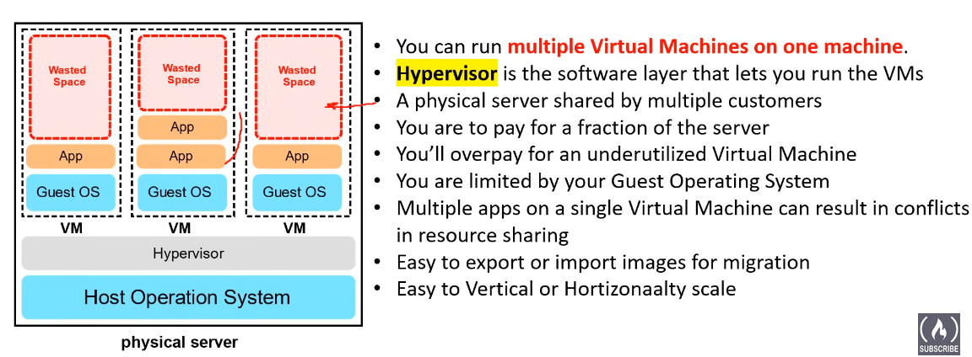

**Note:** A hypervisor, also known as a Virtual Machine Monitor (VMM), is a software or firmware that enables the creation and management of virtual machines (VMs). A virtual machine is an emulation of a computer system that runs on a physical host machine. The hypervisor sits between the hardware of the host system and the virtual machines, facilitating the sharing of physical resources among multiple VMs.

1. Containers:

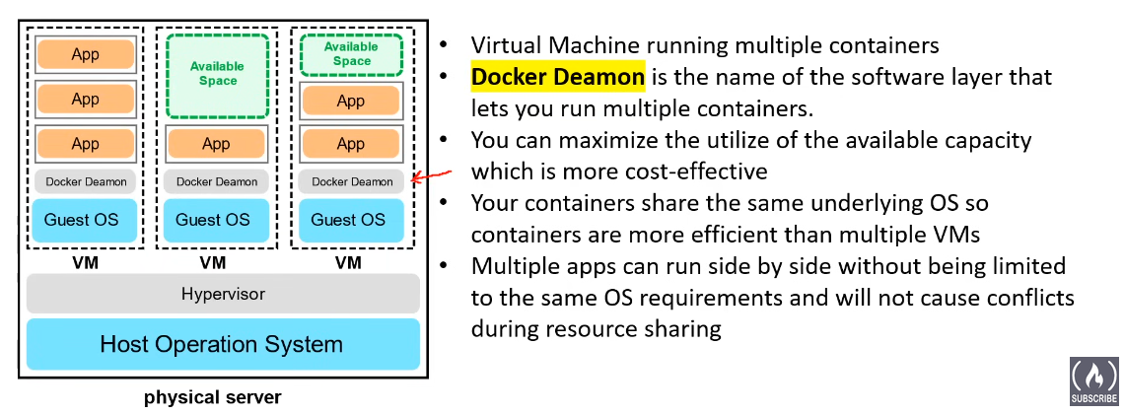

**Note:** Containers are lightweight packages of your application code together with dependencies such as specific versions of programming language runtimes and libraries required to run your software services.

**Example:**

Imagine you have a shipping container. It contains everything a product needs to run: the product itself, any tools it requires, and instructions on how to run it. In the world of computing, a container is similar—it packages an application and its dependencies together.

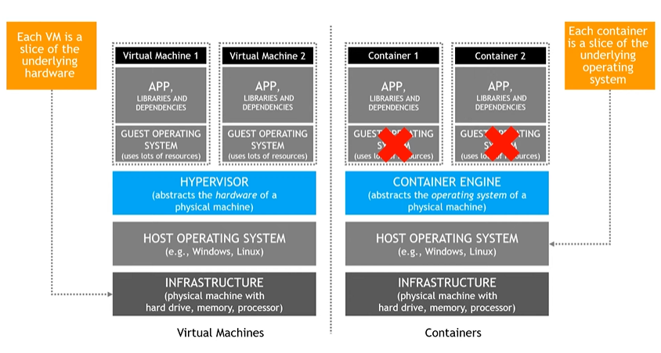

**Example: Web Application Deployment**

1. **Virtual Machines (VMs):**

* Imagine you have a traditional monolithic web application that consists of multiple components, such as a web server, application server, and database server. Each of these components has specific OS and software dependencies.
* In a VM-based deployment:
* You create separate VMs for the web server, application server, and database server.
* Each VM has its own operating system (e.g., Ubuntu, Windows Server) and is configured with the required software stack.
* The VMs run on a hypervisor (e.g., VMware, Hyper-V), which manages the virtualization layer.
  + Pros:
    - Strong isolation: Each component runs in its own VM, providing isolation between the web server, application server, and database.
    - Compatibility: VMs can run different operating systems, allowing you to accommodate diverse software requirements.
  + Cons:
    - Resource overhead: VMs consume more resources due to the duplication of OS and virtualized hardware.
    - Slower scaling: Starting and stopping VMs take more time compared to containers.

1. **Containers:**

* Now, consider the same web application, but this time, you decide to containerize each component using Docker.
* In a container-based deployment:
* You create containers for the web server, application server, and database, each encapsulating the application and its dependencies.
* Containers share the same OS kernel but run in isolated user spaces.
* Container orchestration tools like Kubernetes manage the deployment, scaling, and networking of these containers.
  + Pros:
    - Lightweight: Containers have minimal overhead, making them lightweight and efficient.
    - Rapid scaling: Containers can be quickly started and stopped, enabling rapid scaling based on demand.
    - Portability: Containers can run consistently across different environments, providing high portability.
  + Cons:
    - Weaker isolation: Containers share the host OS kernel, offering less isolation compared to VMs.
    - Limited to the same OS kernel: All containers must run on the same type of OS kernel.

**Conclusion:**

* If the web application has diverse OS requirements or requires strong isolation between components, a VM-based deployment might be more suitable. Each component can run in its own VM, ensuring compatibility and isolation.
* If the application is composed of microservices that can share the same OS kernel and require rapid scaling and portability, a container-based deployment using technologies like Docker and Kubernetes may be preferred.

4. Functions:

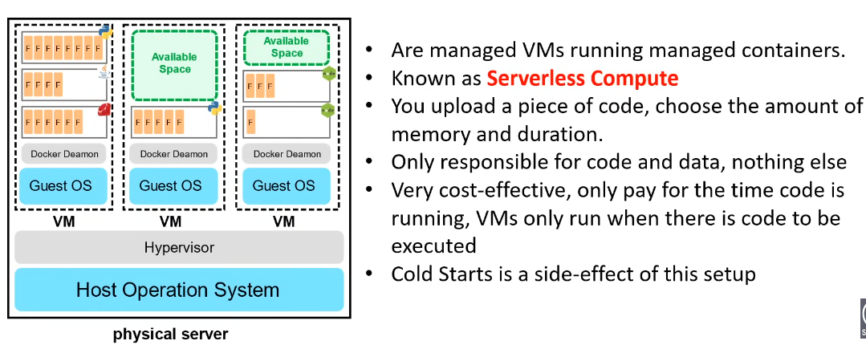

Serverless functions, often referred to as functions as a service (FaaS), allow you to run individual functions or pieces of code without worrying about the underlying server or infrastructure.

**Example:** In the realm of cloud computing, services like AWS Lambda act as the "buttons" that trigger specific functions (code) to run in response to events (triggers), without managing the servers or infrastructure.

**Serverless Functions:** Like automated buttons triggering specific tasks, such as preparing coffee, in response to events without needing direct management of the underlying infrastructure.

## Types of Cloud Computing:

1. **SAAS (Software as a service):**

Software as a Service (SaaS) is a cloud computing service model that provides software applications over the internet. In a SaaS model, users access the software and its features through a web browser without the need for downloading, installing, or maintaining the application on their local devices.

**Key Characteristics of SaaS:**

1. **Accessibility:** Applications are accessible through a web browser, and users can typically access the software from any device with internet connectivity.
2. **Subscription-Based:** SaaS is often subscription-based, where users pay a recurring fee to use the software. This model eliminates the need for upfront costs associated with traditional software licenses.
3. **Managed by the Provider:** The SaaS provider is responsible for maintaining and updating the software, ensuring security, and handling infrastructure management. Users don't need to worry about these aspects.
4. **Scalability:** SaaS applications can scale easily to accommodate varying user loads without requiring users to manage the underlying infrastructure.

E.g., Gmail, Google Workspace, MS Office 365.

1. **PAAS (Platform as a service):**

Platform as a Service (PaaS) is a cloud computing service model that provides a platform allowing customers to develop, run, and manage applications without dealing with the complexities of building and maintaining the underlying infrastructure. PaaS offers a ready-made environment that includes development tools, runtime, and middleware, enabling developers to focus on building and deploying applications rather than managing the underlying infrastructure.

**Key Characteristics of PaaS:**

1. **Development Frameworks:** PaaS provides a development framework that includes tools, libraries, and services needed for building applications. This framework streamlines the development process.
2. **Managed Infrastructure:** The underlying infrastructure, including servers, storage, and networking, is abstracted, and managed by the PaaS provider. Developers don't need to worry about infrastructure management tasks.
3. **Scalability:** PaaS platforms often provide automatic scalability, allowing applications to scale easily based on demand without manual intervention.
4. **Application Hosting:** PaaS allows developers to deploy and host their applications on the platform without managing the server configurations. Deployment and scaling are typically simplified.

E.g., Heroku, Microsoft Azure App Service, Google App Engine

1. **IAAS (Infrastructure as a service):**

Infrastructure as a Service (IaaS) is a cloud computing service model that provides virtualized computing resources over the internet. With IaaS, customers can rent virtualized hardware, including computing power, storage, and networking resources, on a pay-as-you-go basis. IaaS allows organizations to scale their infrastructure up or down based on demand without the need to invest in and maintain physical hardware.

**Key Characteristics of IaaS:**

1. **Virtualization:** IaaS utilizes virtualization technology to abstract and pool computing resources, making them available for users on a virtualized platform.
2. **On-Demand Resources:** Users can provision and deprovision resources on-demand, paying only for the resources they consume. This provides cost flexibility and scalability.
3. **Self-Service:** IaaS platforms typically offer self-service interfaces that allow users to provision and manage resources without direct human intervention.
4. **Scalability:** IaaS enables automatic scaling of resources based on demand, allowing users to handle varying workloads without manual intervention.

E.g., AWS, MS Azure, Google Cloud Platform

## Shared Responsibility Model:

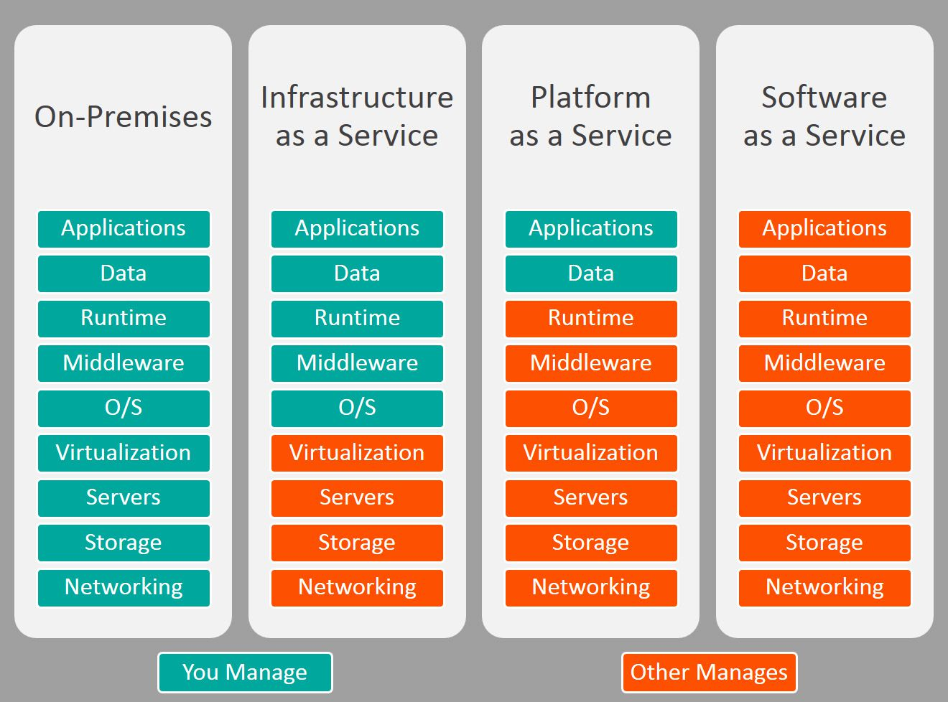

## Cloud Computing Deployment Model:

1. **Public Cloud:**

A public cloud refers to a cloud computing environment that is owned and operated by a third-party cloud service provider and made available to the public. In a public cloud, computing resources such as virtual machines, storage, and networking are shared among multiple customers and organizations, and these resources are delivered over the internet.

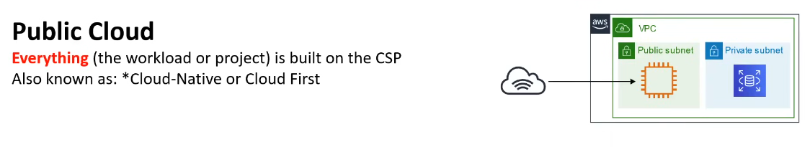**Public Subnet:**

A public subnet is a subnet in which the instances (such as EC2 instances) can communicate directly with the internet. To enable internet access, instances in a public subnet typically have an Elastic IP address (EIP) or a public IP address associated with them, and the subnet's route table is configured to route traffic to the internet through an Internet Gateway

**Private Subnet:**

A private subnet is a subnet in which instances do not have direct internet access. Instances in a private subnet can communicate with other instances within the same VPC and can also communicate with the internet through a Network Address Translation (NAT) gateway or NAT instance in the public subnet. Hosting databases, application servers, or backend services that don't need direct internet exposure.

1. **Private Cloud:**

A private cloud refers to a cloud computing environment that is exclusively used by a single organization. In a private cloud, the computing resources—such as servers, storage, and networking—are provisioned for the exclusive use of that organization. Unlike public clouds, private clouds are not shared with other organizations, and the infrastructure can be physically located on-premises or hosted by a third-party service provider.

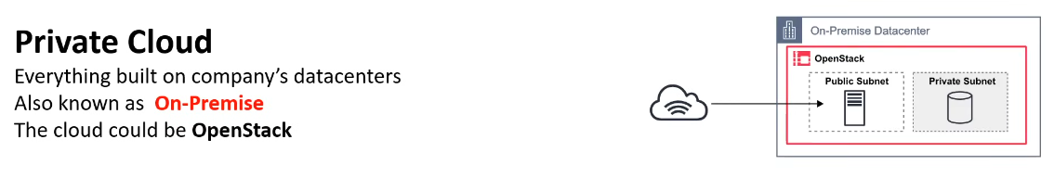

**Deployment Models for Private Clouds:**

1. **On-Premises Private Cloud:** The private cloud infrastructure is located within the organization's own data centers. This model provides complete control but requires the organization to invest in and manage the physical hardware.
2. **Hosted Private Cloud:** The private cloud infrastructure is hosted and managed by a third-party service provider. The provider takes care of hardware management, allowing the organization to focus on using and configuring the cloud services.

**3. Hybrid Cloud:**

A hybrid cloud is a computing environment that combines elements of both public and private clouds. In a hybrid cloud setup, data and applications can move between private and public cloud infrastructure seamlessly. This provides greater flexibility and more deployment options.

Implementing a hybrid cloud strategy involves careful planning and integration to ensure seamless communication and data transfer between the public and private components. This approach allows organizations to leverage the benefits of both public and private clouds based on their specific needs and requirements.

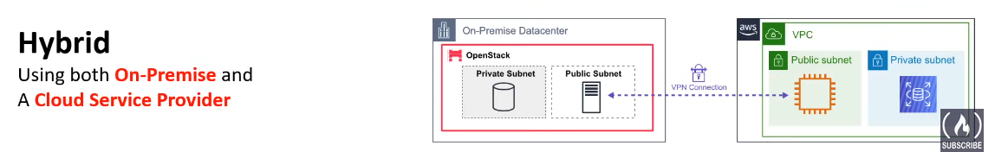

**4. Cross Cloud:**

"Cross-cloud" typically refers to a computing environment or solution that spans multiple cloud platforms. In other words, it involves the use and integration of services and resources from different cloud providers. This approach contrasts with a single-cloud strategy where an organization relies solely on one cloud service provider for its computing needs.

The concept of cross-cloud computing has become more relevant as organizations seek to avoid vendor lock-in, increase flexibility, and optimize their use of cloud resources. By adopting a cross-cloud strategy, businesses can select services from different cloud providers based on factors such as cost, performance, geographic availability, and specific features offered by each provider.

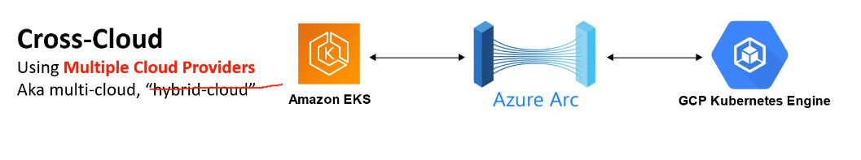

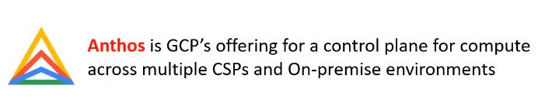

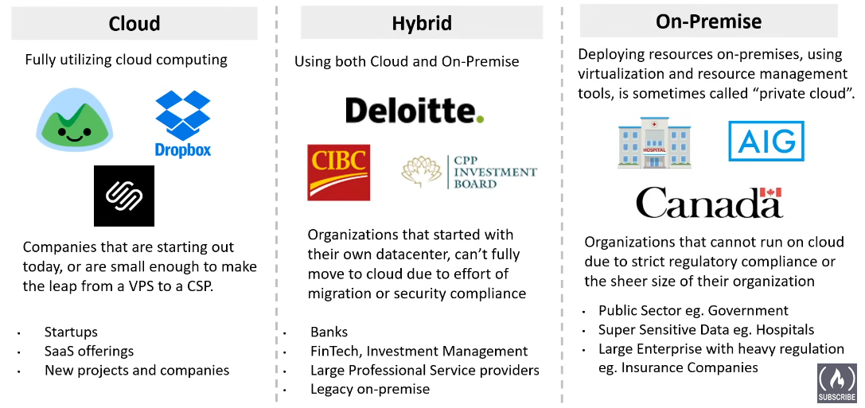

## What is IAM?

AWS Identity and Access Management (IAM) is a web service that helps you securely control access to AWS resources. You use IAM to control who is authenticated (signed in) and authorized (has permissions) to use resources.

### **IAM: Users & Groups**

* IAM = Identity and Access Management, Global service
* **Root account** created by default, shouldn’t be used, or shared.
* **Users** are people within your organization and can be grouped.
* **Groups** only contain users, not other groups.
* Users don’t have to belong to a group, and users can belong to multiple groups.

## How to Create an IAM User?

Creating an IAM (Identity and Access Management) user in AWS involves several steps. IAM allows you to manage access to AWS services and resources securely. Here's a step-by-step guide on how to create an IAM user:

**Step 1: Sign in to the AWS Management Console**

1. Open your web browser and go to the https://aws.amazon.com/

2. Sign in with your AWS account credentials.

**Step 2: Navigate to IAM**

1. In the AWS Management Console, search for "IAM" or find it under the "Security, Identity, & Compliance" section.

2. Click on "IAM" to open the IAM dashboard.

**Step 3: Access the Users Section**

1. In the IAM dashboard, select "Users" from the left-hand navigation pane.

**Step 4: Create a New IAM User**

1. Click the "Create user" button.

2. Enter a username for the new IAM user.

**Step 5: Set User Permissions**

1. Choose the type of access for the user:

* Programmatic access: Allows the user to interact with AWS services using the AWS CLI, SDKs, or other API-based tools.
* AWS Management Console access: Allows the user to sign in to the AWS Management Console.

2. Based on your selection, set permissions accordingly:

* Attach policies directly: Attach existing policies to grant the necessary permissions.
* Add user to group: Add the user to a group that has predefined policies.
* Copy permissions from existing user: Copy permissions from an existing user.

**Step 6: Configure Tags (Optional)**

You can add tags to help identify and organize your users. Tags consist of key-value pairs.

**Step 7: Complete the User Creation**

Click the "Create user" button.

## How can users access AWS?

* To access AWS, you have three options:
  + AWS Management Console (protected by password + MFA)
  + AWS Command Line Interface (CLI): protected by access keys.
  + AWS Software Developer Kit (SDK) - for code: protected by access keys.
* Access Keys are generated through the AWS Console
* Users manage their own access keys.
* Access Keys are secret, just like a password. Don’t share them.
* Access Key ID ~= username
* Secret Access Key ~= password

## How to create an AWS Budget and get an alert on reaching the threshold:

Setting a budget and configuring alerts in AWS can help you manage your costs effectively and avoid unexpected expenses. AWS Budgets allows you to set custom cost and usage budgets that alert you when you exceed your thresholds. Here's a step-by-step guide on how to set up a budget and alerts in AWS:

**Step 1: Sign in to the AWS Management Console**

1. Open your web browser and go to the (https://aws.amazon.com/).

2. Sign in with your AWS account credentials.

**Step 2: Navigate to the AWS Budgets Console**

1. In the AWS Management Console, search for "Budgets" or find it under the "Billing" section.

2. Click on "Budgets" to open the AWS Budgets console.

**Step 3: Create a New Budget**

1. Click on the "Create budget" button.

**Step 4: Choose Budget Type**

1. Select the "Cost budget" option to set a budget based on the total cost or "Usage budget" for usage-based budgets.

2. Click "Continue."

**Step 5: Configure Budget Details**

1. Budget Details:

- Enter a name for your budget.

- Choose your budget period (monthly, quarterly, or annually).

- Choose the start and end dates for the budget.

2. Budget Amount:

- Enter the budgeted amount. This is the threshold that triggers an alert when exceeded.

3. Additional Options (Optional):

- You can configure additional options, such as choosing specific AWS accounts or services to include or exclude from the budget.

**Step 6: Configure Alerts**

1. Under "Configure alerts," you can set up notifications when your budget exceeds a certain threshold.

- Click "Add notification" to configure an alert.

- Enter the percentage or amount at which you want to receive an alert.

- Choose the notification type (Amazon SNS or Email).

- Add the notification details.

- Click "Add."

**Step 7: Create Budget**

1. Press the create budget and the budget will be created.

By setting up budgets and alerts, you can proactively monitor your AWS spending and take action to control costs as needed. Adjust your budgets over time based on your usage patterns and business requirements.

## Billing Alerts through AWS CloudWatch:

AWS Billing and Cost Management provides the ability to set up billing alerts using Amazon CloudWatch. With CloudWatch Alarms, you can monitor your estimated charges and get notified when the costs exceed a certain threshold. Here's a step-by-step guide on how to set up billing alerts through CloudWatch:

### **Step 1: Sign in to the AWS Management Console**

1. Open your web browser and go to theAWS Management Console.
2. Sign in with your AWS account credentials.

### **Step 2: Navigate to CloudWatch**

1. In the AWS Management Console, search for "CloudWatch" or find it under the "Management & Governance" section.
2. Click on "CloudWatch" to open the CloudWatch console.

### **Step 3: Create a Billing Alarm**

1. In the CloudWatch console, navigate to the "Alarms" section in the left-hand navigation pane, and click the billing section.
2. Click on the "Create Alarm" button.

### **Step 4: Select Metric**

1. Under "Select metric," choose the "Billing" metric namespace.
2. Select the "Total Estimated Charge" metric.

### **Step 5: Define Conditions**

1. Define the conditions for the alarm:
   * Choose a statistic (e.g., "Maximum").
   * Set the period (e.g., "1 hour").
   * Set the threshold value for which you want to receive an alert.

### **Step 6: Configure Actions**

1. Under "Actions," click on the "Add notification" button to configure the notification.
2. Choose an existing SNS (Simple Notification Service) topic or create a new one.
3. Enter the email addresses or endpoint ARNs to receive notifications.
4. Click "Create Alarm" to finish.

### **Step 7: Review and Create**

1. Review your settings to ensure they are correct.
2. Click "Create Alarm" to create the billing alarm.

### **Step 8: Confirm Subscription (If Using Email)**

If you're using email notifications, you might need to confirm the subscription by clicking a confirmation link in the email sent to the specified email addresses.

### **Step 9: Monitor Billing Alarms**

Once the alarm is created, it will actively monitor your estimated charges. If the charges exceed the defined threshold, CloudWatch will trigger the alarm, and notifications will be sent to the configured SNS topic or email addresses.

By setting up billing alarms through CloudWatch, you can receive timely notifications and take proactive measures to manage and control your AWS costs. Adjust the alarm threshold as needed based on your budget and cost management requirements.

## Difference between AWS Budgets and CloudWatch Alarms:

### **Key Differences:**

* **Focus:**
  + AWS Budgets is focused on cost management and budget tracking.
  + CloudWatch Alarms are focused on monitoring various metrics for AWS resources and taking actions based on conditions.
* **Scope:**
  + AWS Budgets provides a higher-level view of spending across different dimensions.
  + CloudWatch Alarms are specific to individual metrics associated with resources.
* **Granularity:**
  + AWS Budgets can operate at different levels of granularity, including overall costs and specific services.
  + CloudWatch Alarms are more focused on monitoring specific metrics associated with individual resources.

In summary, while both AWS Budgets and CloudWatch Alarms are valuable tools for monitoring and managing AWS resources, they serve different purposes. AWS Budgets is specialized for cost tracking, whereas CloudWatch Alarms are versatile and used for monitoring various metrics associated with AWS resources. Depending on your specific needs, you may choose to use one or both tools in combination to effectively manage your AWS environment.

## Evolution of Computing Power:

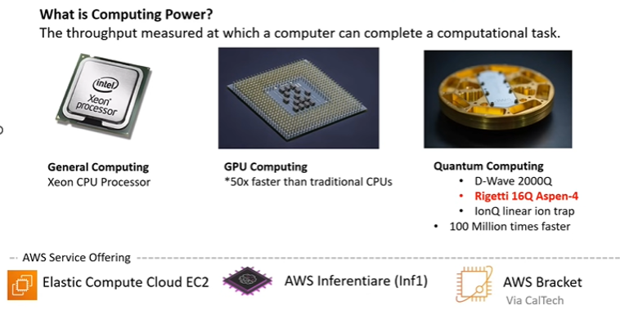

Six Advantages of Cloud:

**Trade fixed expense for variable expense** – Instead of having to invest heavily in data centers and servers before you know how you’re going to use them, you can pay only when you consume computing resources, and pay only for how much you consume.

**Benefit from massive economies of scale** – By using cloud computing, you can achieve a lower variable cost than you can get on your own. Because usage from hundreds of thousands of customers is aggregated in the cloud, providers such as AWS can achieve higher economies of scale, which translates into lower pay as-you-go prices.

**Stop guessing capacity** – Eliminate guessing on your infrastructure capacity needs. When you make a capacity decision prior to deploying an application, you often end up either sitting on expensive idle resources or dealing with limited capacity. With cloud computing, these problems go away. You can access as much or as little capacity as you need and scale up and down as required with only a few minutes’ notice.

**Increase speed and agility** – In a cloud computing environment, new IT resources are only a click away, which means that you reduce the time to make those resources available to your developers from weeks to just minutes. This results in a dramatic increase in agility for the organization since the cost and time it takes to experiment and develop is significantly lower.

**Stop spending money running and maintaining data centers** – Focus on projects that differentiate your business, not the infrastructure. Cloud computing lets you focus on your own customers, rather than on the heavy lifting of racking, stacking, and powering servers.

**Go global in minutes** – Easily deploy your application in multiple regions around the world with just a few clicks. This means you can provide lower latency and a better experience for your customers at minimal cost.

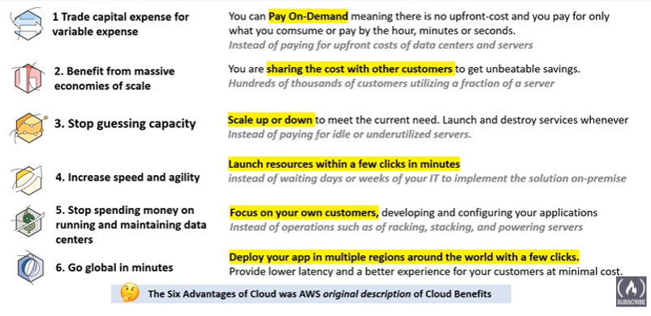

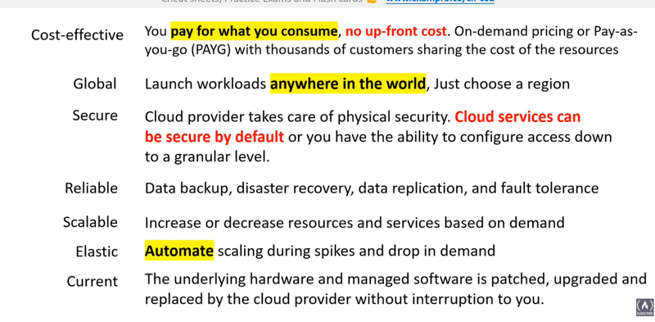

AWS Global Infrastructure Regions:

AWS regions are geographically dispersed data centers that house Amazon Web Services (AWS) resources. Each region consists of multiple Availability Zones, providing redundancy and fault tolerance. AWS users can deploy their applications and services in different regions to enhance performance, resilience, and compliance with regional data protection laws. Examples of AWS regions include us-east-1 (North Virginia), eu-west-2 (London), and ap-southeast-1 (Singapore).

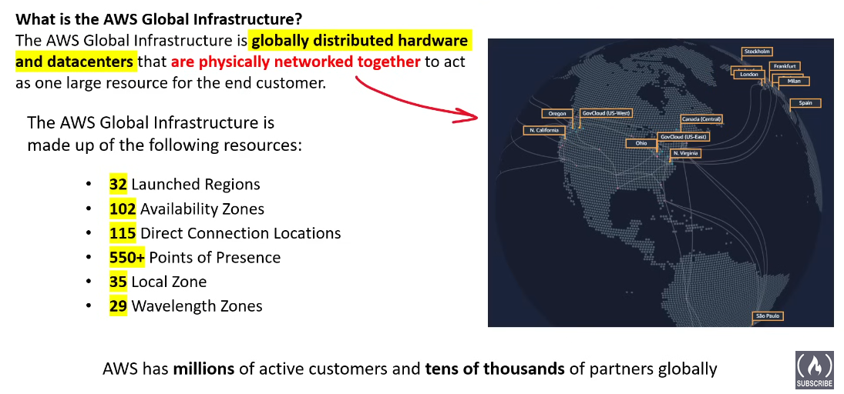

Regions:

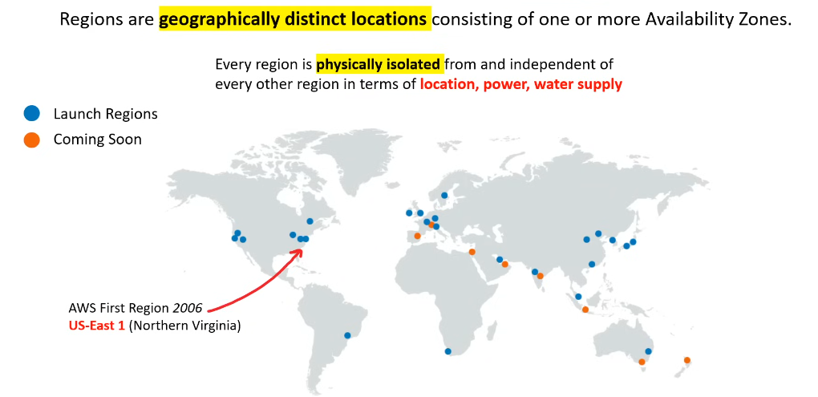

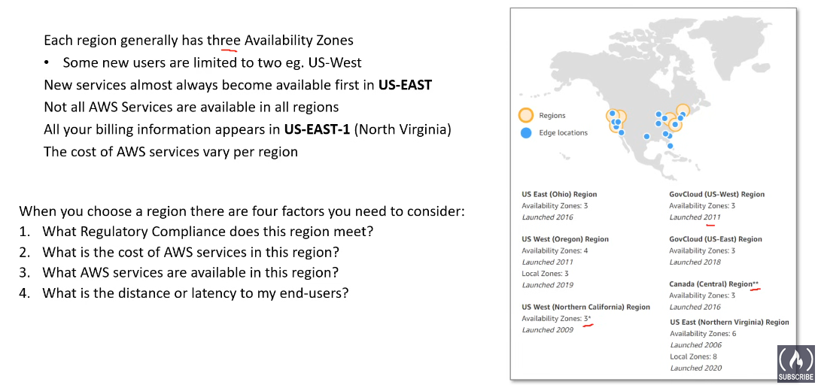

Regional Vs Global Services:

* **Regional services** are AWS services that operate within a specific geographical region. AWS has multiple regions around the world, and each region is a separate geographic area that consists of multiple availability zones.
* **Characteristics**:

1. Services are deployed and managed within a specific region.
2. Data stored in regional services is confined to that region.
3. Examples of regional services include Amazon EC2, Amazon RDS.

* **Advantages**:

1. Compliance: Some organizations and regulations require data to be stored within specific geographic boundaries.
2. Latency: Locating services close to users reduces latency and improves performance.
   * **Global services**, on the other hand, operate across multiple regions and are designed to provide a unified experience or service globally.

* **Characteristics:**
  1. Services that are globally distributed and managed centrally.
  2. Data and content served globally from edge locations using Content Delivery Network (CDN) services like Amazon CloudFront.
  3. Examples of global services include Amazon CloudFront (CDN), AWS Identity and Access Management (IAM), and AWS Key Management Service (KMS).
* **Advantages:**

1. Global Reach: Services that can be accessed and utilized globally, providing consistency and accessibility across regions.
2. Centralized Management: Some services offer a centralized management interface or configuration that spans multiple regions.

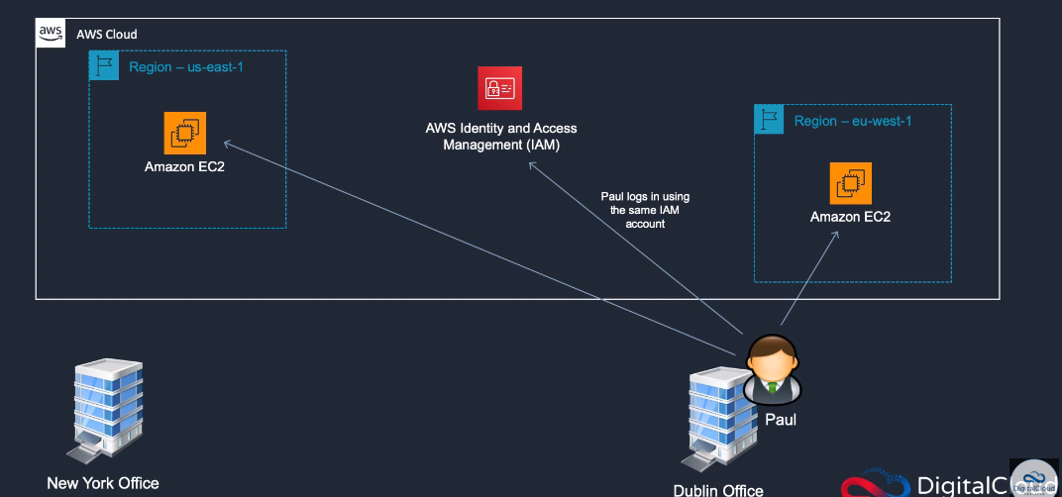

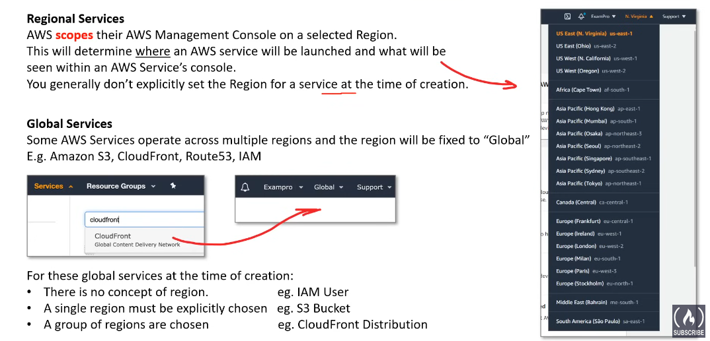

AWS Availability Zones:

Availability Zone (AZ) is a distinct location within a region that is designed to be isolated from other Availability Zones in the same region. The purpose of Availability Zones is to provide redundancy, fault tolerance, and high availability for AWS services and applications.  
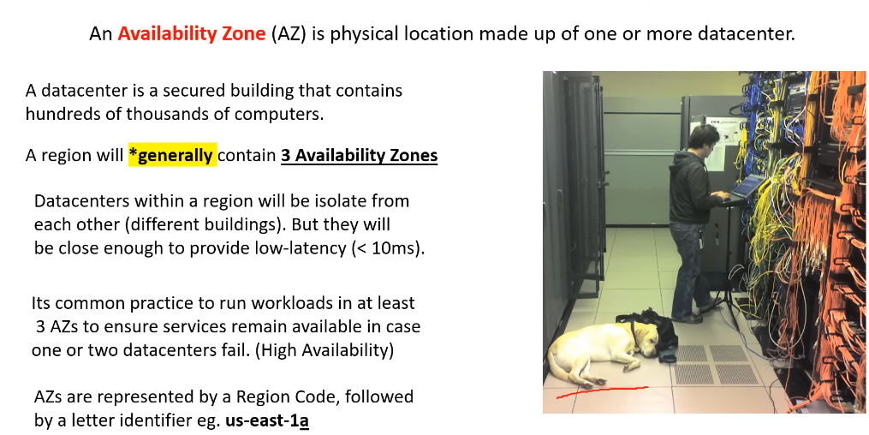

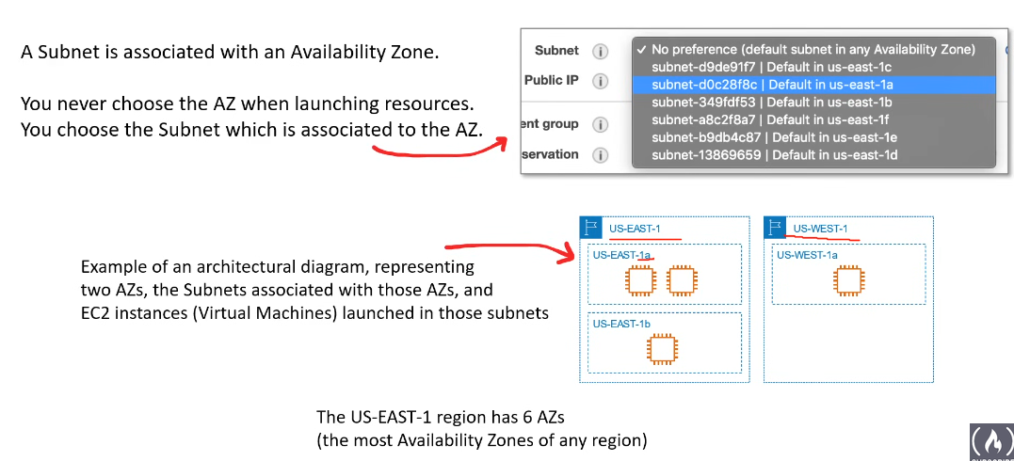

Key Characteristics of Availability Zones:

* **Isolation:**

Availability Zones are physically separated data centers within a region. They are typically located in separate buildings, with independent power, cooling, and networking infrastructure.

The isolation is designed to minimize the impact of failures and disasters, ensuring that if one Availability Zone experiences an issue, the others can continue to operate.

* **Redundancy:**

Services deployed across multiple Availability Zones can achieve redundancy. If one zone becomes unavailable, the application can continue to operate from another zone without interruption.

Redundancy across Availability Zones is a fundamental building block for achieving high availability and fault tolerance in AWS.

* **Low Latency:**

Availability Zones within a region are interconnected by a high-bandwidth, low-latency network. This enables fast and reliable communication between resources deployed in different zones.

* **AWS Services:**

Many AWS services, such as Amazon EC2, Amazon RDS, and Amazon S3, allow users to deploy resources across multiple Availability Zones to enhance availability and fault tolerance.

When deploying applications on AWS, it is a best practice to distribute resources across multiple Availability Zones to achieve high availability and resilience. This can be achieved by using load balancers, deploying databases with multi-AZ configurations, and ensuring that critical components of the infrastructure are designed to tolerate the failure of an individual Availability Zone.

It's important to note that while Availability Zones provide a high level of redundancy, overall resilience and disaster recovery planning should also include considerations for multi-region strategies. AWS customers often combine the use of Availability Zones within a region with multi-region architectures for critical applications.

**Examples:**

* + - 1. **Amazon EC2 Instances:** When launching Amazon EC2 instances (virtual servers) in AWS, users can deploy instances across multiple Availability Zones to distribute the workload and ensure high availability. This is commonly achieved using an Auto Scaling group that spans multiple zones.
      2. **Amazon RDS Multi-AZ Deployments:** Amazon RDS (Relational Database Service) allows users to create a multi-AZ deployment for database instances. In this setup, a primary database is automatically replicated to a standby instance in a different Availability Zone. If the primary database becomes unavailable, the standby can be promoted to the primary role.
      3. **Amazon S3 Cross-Region Replication:** Although not directly related to Availability Zones, Amazon S3 (Simple Storage Service) provides cross-region replication for data redundancy. Users can replicate objects between S3 buckets in different regions to ensure data availability in case of a regional outage.

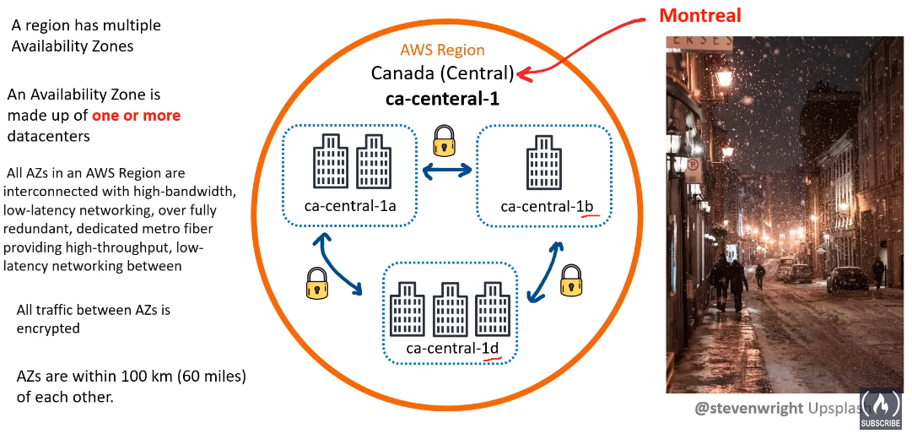

Subnets:

[In the context of Amazon Web Services (AWS), subnets are logical subdivisions of a Virtual Private Cloud (VPC) that allow you to partition and organize your resources within a VPC](https://www.testpreptraining.com/blog/what-are-aws-subnets/). [**Each subnet has its own unique IP address range and can be associated with a different availability zone (AZ) within a region**](https://www.testpreptraining.com/blog/what-are-aws-subnets/)**.**

You can create AWS resources, such as EC2 instances, in specific subnets. By launching AWS resources in separate Availability Zones, you can protect your applications from the failure of a single Availability Zone.

Examples:

* When we lauch a EC2 Instance, we are propmpted to choose a Subnet(AZ’s), where we want to lauch the instance.
* When we lauch a S3 Bucket , we are only prompted to choose a Region not a AZ’s because , AWS will run multiple instance of the buckets in different AZ’s to ensure avilability.
* When we use CloudFront(CDN : Content Delivery Network) we are only supposed to select geographical locations.
* If we are using services like IAM we don’t even have to specify any region or az as they are available globally for use.

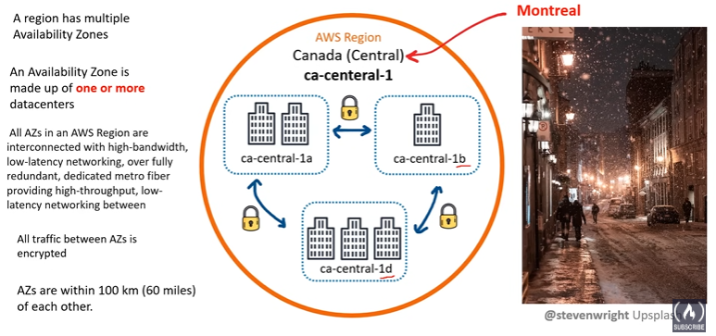

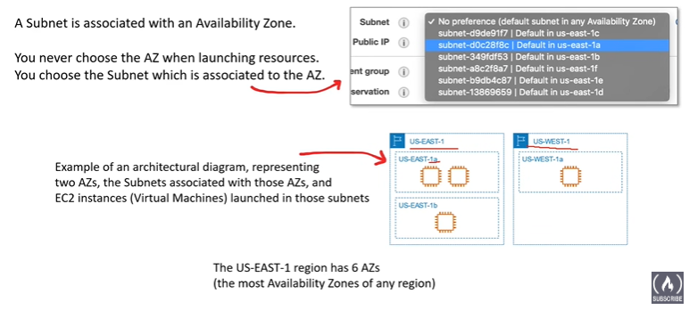

AWS Fault Tolerance: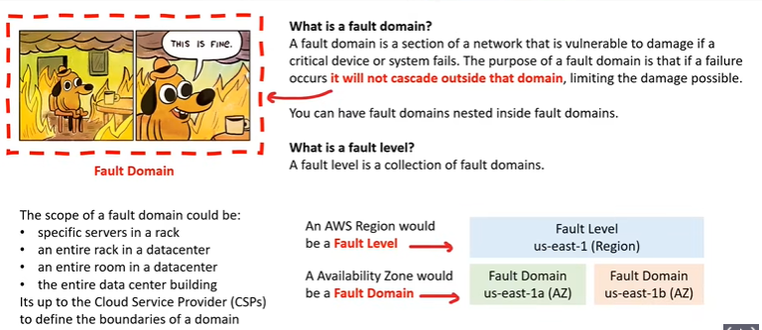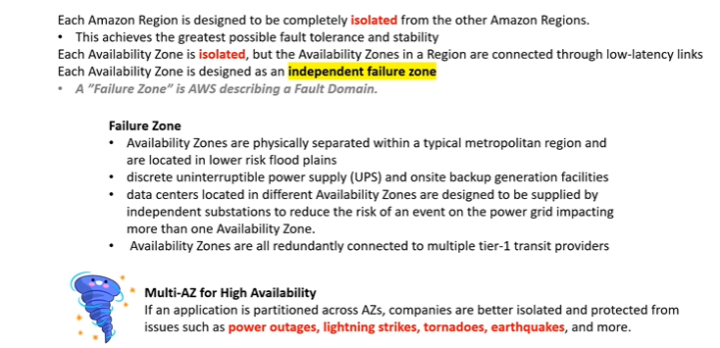

AWS Global Network:

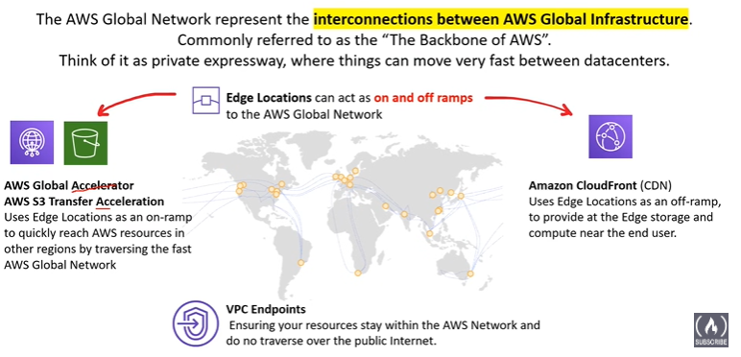

* **Edge Locations**: AWS Edge Locations are physical locations deployed in major cities around the world, closer to users than AWS Regions or Availability Zones. They are designed to deliver AWS services with minimal latency.

While Edge Locations are used to cache data and provide low latency, Availability Zones are used for hosting and running applications and services. Both are crucial components of AWS’s infrastructure, each serving a unique purpose to ensure efficient and reliable service delivery. They differ physically in terms of their size, location, and the type of hardware and infrastructure they house. Edge Locations are typically smaller and spread out across many major cities globally for caching and content delivery, while Availability Zones are larger data centers located in specific regions for hosting applications and services.

* **AWS Global Accelerator** act as a global traffic manager for your applications. It uses AWS's vast network to direct user requests to the nearest and healthiest server, reducing latency and enhancing performance. Essentially, it optimizes how your app handles traffic on a global scale, ensuring a smoother and faster experience for users worldwide.

AWS Global Accelerator leverages edge locations strategically. Edge locations are part of the AWS Content Delivery Network (CDN), known as Amazon CloudFront. When a user makes a request to your application, Global Accelerator uses these edge locations to route the traffic to the closest healthy endpoint.

Here's how it works:

**1**. **User Requests**: When a user requests access to your application, the request is sent to the nearest edge location.

**2.** **Global Accelerator Routing:** Global Accelerator then routes the traffic through the AWS global network to the optimal endpoint, considering factors like health, proximity, and routing policies.

**3. Endpoint Delivery:** The user is served by the selected endpoint, which could be hosted in different AWS regions, improving the overall performance and availability of your application.

* **AWS S3 Transfer Acceleration** is a feature provided by Amazon Simple Storage Service (S3) to accelerate uploading and downloading of objects to and from your S3 buckets. It utilizes the CloudFront content delivery network to speed up transfers.

Here's how it works:

1. **Accelerated Endpoints:** When you enable Transfer Acceleration for an S3 bucket, you get a unique accelerated endpoint (e.g., `bucket-name.s3-accelerate.amazonaws.com`).

2. **CloudFront Distribution**: Behind the scenes, AWS sets up a CloudFront distribution for your accelerated endpoint. CloudFront uses a network of edge locations globally.

3. **Optimized Routes**: When you upload or download objects using the accelerated endpoint, the traffic is automatically routed through the optimized CloudFront network, reducing latency and improving transfer speeds.

It's important to note that while S3 Transfer Acceleration can significantly speed up data transfers, the actual performance improvement depends on factors such as the geographic locations of your users and the size of the objects being transferred.

* **AWS CloudFront** is a content delivery network (CDN) service provided by Amazon Web Services. Its primary purpose is to deliver static and dynamic web content, including images, videos, scripts, and other files, to users globally with low latency and high transfer speeds.

Key features of AWS CloudFront include:

1. **Global Edge Locations**: CloudFront has a network of edge locations around the world. When a user requests content, CloudFront delivers it from the nearest edge location, reducing latency and enhancing performance.

2. **Content Caching**: CloudFront caches content at edge locations, storing copies of your static content closer to users. This reduces the load on your origin server and improves response times.

3. **Integration with Other AWS Services**: CloudFront seamlessly integrates with other AWS services, such as Amazon S3, EC2, and Lambda, making it easy to deliver content stored in these services with low latency.

AWS Point of Presence:

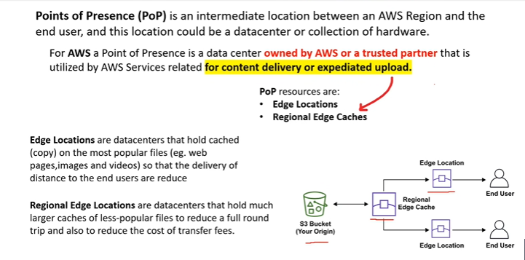

**Points of Presence (PoPs)** refer to the locations where AWS deploys infrastructure to improve the delivery of its services, particularly for content delivery and edge computing. These PoPs are strategically positioned in various regions worldwide to reduce latency and improve performance for end-users accessing AWS services.

Key points about AWS Points of Presence:

**1. Content Delivery:** AWS PoPs are often associated with Amazon CloudFront, a content delivery network (CDN) service. These PoPs help in distributing content (e.g., images, videos) to end-users globally with lower latency.

**2. Edge Locations:** AWS PoPs are sometimes referred to as "edge locations." These are distinct from AWS Regions and Availability Zones. While Regions and Availability Zones house the primary infrastructure, edge locations (PoPs) are distributed to the edges of the AWS network to bring services closer to end-users and reduce latency of data to travel, improving the overall responsiveness of applications.

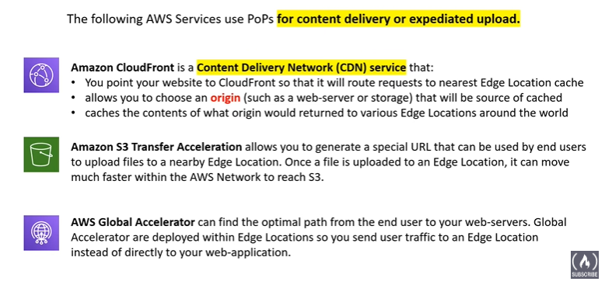

AWS Direct Connect:

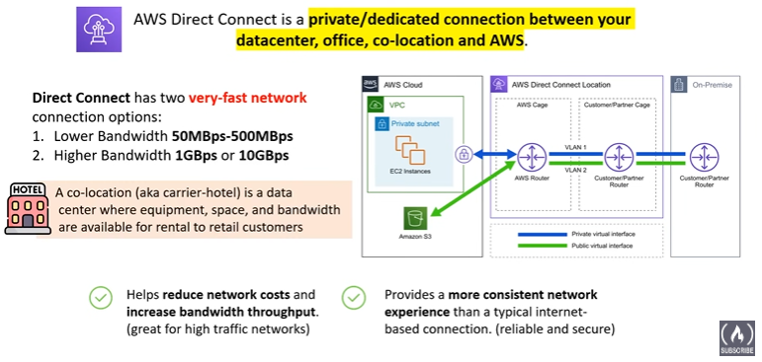

* Direct Connect Locations:

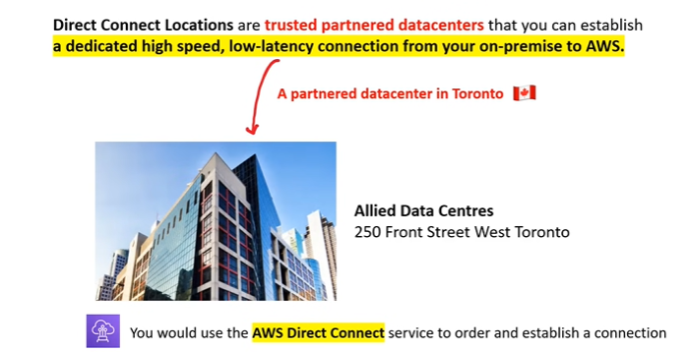

AWS Local Zones:

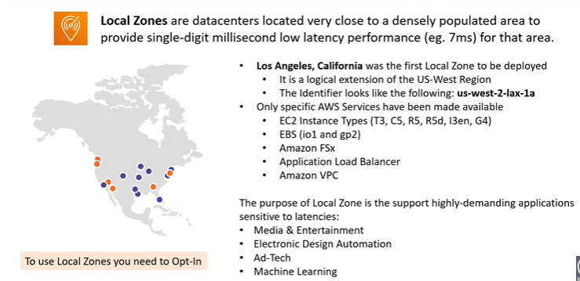

**AWS Local Zones** are an extension of AWS infrastructure designed to bring AWS services closer to end-users and applications in specific geographic locations. Local Zones are smaller, geographically dispersed **data centers** connected to an AWS Region, providing low-latency access to certain AWS services. They are phyical facilities with computing and storage resources.

Key features of AWS Local Zones:

**1. Low-Latency Access:** Local Zones are intended to reduce latency for applications that require single-digit millisecond latencies. They bring AWS resources closer to end-users, improving performance for applications sensitive to latency.

**2. Selective Service Availability:** AWS Local Zones offer a subset of AWS services and are specifically designed to support use cases such as content creation, media and entertainment, real-time gaming, and machine learning inference.

**3. Connected to AWS Region:** Local Zones are connected to a parent AWS Region. This connection allows seamless integration with the broader range of AWS services available in the associated region.

AWS Local Zones and AWS Edge Locations are both components of AWS's strategy to enhance the performance and availability of services, but they serve different purposes and have distinct characteristics.

**Diffrence between AWS Local Zones are Edge Locations:**

**AWS Local Zones:**

**1. Purpose:** Local Zones are designed to bring AWS resources closer to end-users in specific geographic locations, providing low-latency access to a subset of AWS services.

**2. Size and Scope**: Local Zones are smaller, geographically dispersed data centers connected to a specific AWS Region. They are intended to address the needs of customers in metropolitan areas.

**3. Service Availability:** Local Zones offer a selective set of AWS services. The services available in Local Zones are chosen to cater to use cases with low-latency requirements, such as media and entertainment, machine learning, and real-time gaming.

**AWS Edge Locations:**

**1. Purpose:** Edge Locations are part of the Amazon CloudFront content delivery network (CDN) infrastructure. They are strategically located around the world to cache and deliver content, reducing latency for end-users accessing web applications.

**2. Size and Scope:** Edge Locations are numerous and widely distributed. They are often smaller points of presence (PoPs) and are part of a global network to accelerate the delivery of web content.

**3. Service Availability:** Edge Locations primarily support Amazon CloudFront for content delivery but are not designed to provide a broader range of AWS services. They focus on caching and delivering content quickly to end-users.

AWS Local Zones bring AWS services closer to specific geographic locations, emphasizing low-latency access for a subset of services. AWS Edge Locations are part of the CloudFront CDN infrastructure, optimizing content delivery globally. The choice between Local Zones and Edge Locations depends on the specific requirements of the application and the geographic distribution of end-users.

Wavelength Zones:

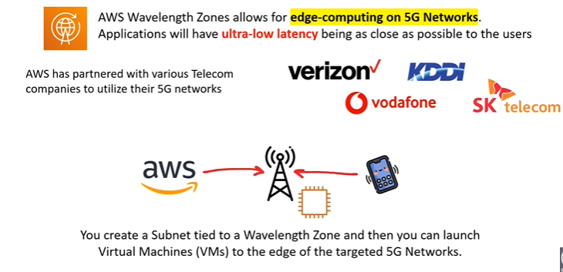

**AWS Wavelength** is an extension of AWS infrastructure designed to bring AWS services to the edge of the 5G networks. Wavelength allows developers to deploy applications that require ultra-low latency directly at the edge of the telecommunications networks, enabling use cases such as augmented reality (AR), virtual reality (VR), and machine learning at the edge.

Key features of AWS Wavelength Zones:

**1. Ultra-Low Latency:** AWS Wavelength Zones are integrated with telecom networks to provide single-digit millisecond latencies. This is crucial for applications that demand real-time responsiveness.

**2. Deployment at the Edge:** Wavelength extends **AWS compute and storage services** to the edge of the 5G networks, placing infrastructure in proximity to end-users and devices.

**3. Close Collaboration with Telecom Providers:** AWS collaborates with telecommunications providers to integrate Wavelength Zones into their networks. This allows developers to leverage both AWS services and the telecom provider's infrastructure.

**4. Compatible with AWS Services:** Wavelength is compatible with various AWS services, allowing developers to build applications with familiar tools and services while taking advantage of the low-latency capabilities.

**5. Use Cases:** Use cases for Wavelength include applications that require real-time interactions, such as AR/VR, gaming, video analytics, and industrial automation.

**AWS Services that uses Wavelength Zones:**

**1.** **Amazon EC2 Instances in Wavelength Zones**: You can deploy Amazon EC2 instances directly within Wavelength Zones to run your applications **at the edge** with low-latency access.

**2. AWS Lambda**: Serverless applications using AWS Lambda can benefit from the low-latency capabilities of Wavelength Zones, enabling real-time processing at the edge.

**3.** **Amazon EBS (Elastic Block Store):** You can use Amazon EBS volumes for storage needs within Wavelength Zones.

**4.** **Amazon VPC (Virtual Private Cloud):** Wavelength extends the Amazon VPC to the edge, allowing you to create isolated network environments for your applications.

**5.** **Amazon RDS (Relational Database Service):** Deploying databases with Amazon RDS in Wavelength Zones can provide low-latency access for applications requiring real-time data processing.

**6.** **AWS IoT Core:** Internet of Things (IoT) applications can leverage Wavelength Zones for real-time processing of IoT data at the edge.

**7.** **Amazon S3 Transfer Acceleration:** Applications that require fast and secure transfers of files and objects can use Amazon S3 Transfer Acceleration in conjunction with Wavelength Zones.

Data Residency:

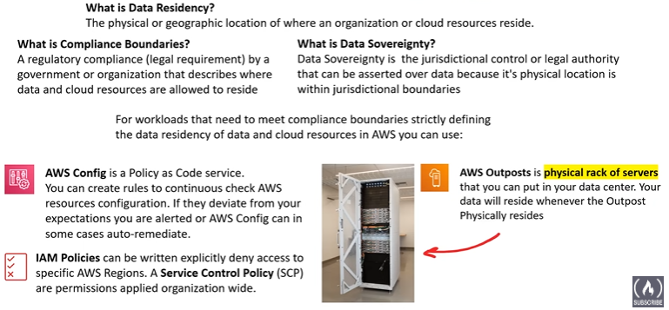

AWS For Government:

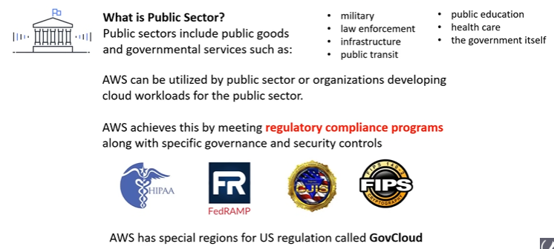

GovCloud:

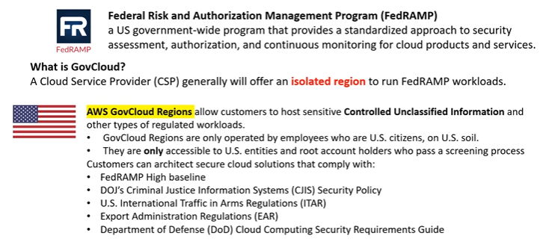

Sustainability for AWS Global Infrastructure:

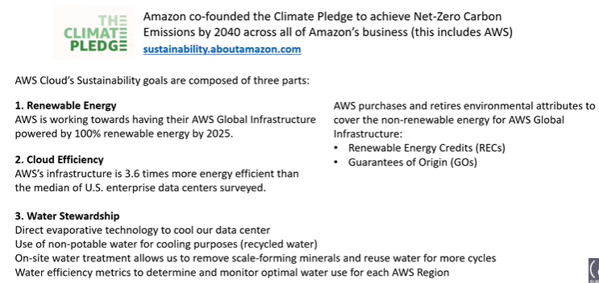

AWS Ground Station:

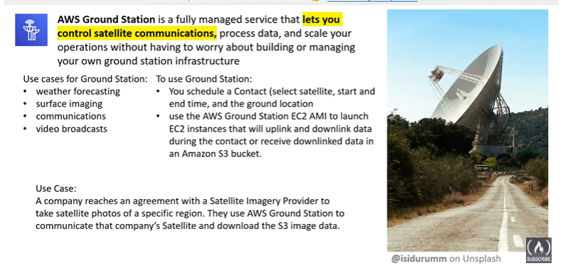

AWS Outpost:

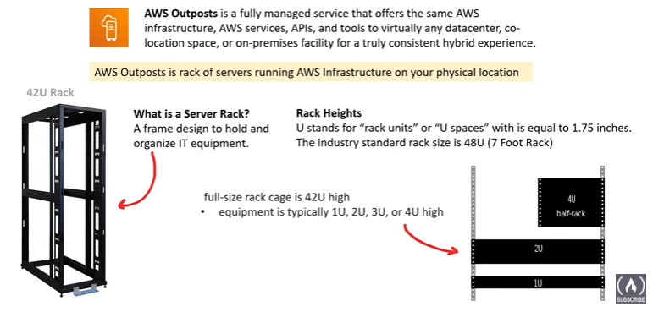

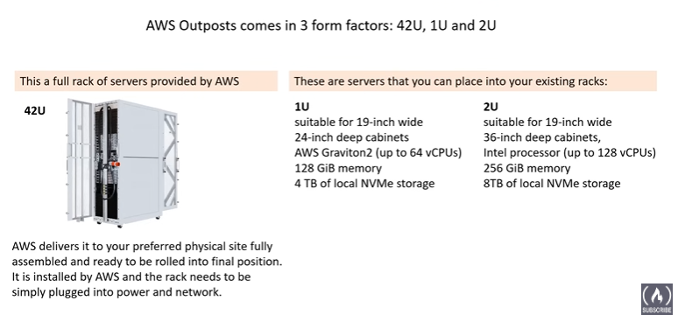

**AWS Outposts** consist of server racks installed on-premises that are fully managed by AWS. Here's a simplified overview of how it works:

**1. Installation:** AWS delivers and installs the Outposts hardware at the customer's on-premises location.

**2. Connection to AWS Region:** Outposts is connected to the nearest AWS Region using AWS Direct Connect or through an internet connection.

**3. Integration with AWS Services:** Once connected, Outposts seamlessly integrates with various AWS services, allowing you to run, monitor, and manage applications using the same AWS tools and APIs.

**4. Local Compute and Storage:** Outposts provide local compute and storage resources, allowing you to run compute instances and store data locally. This is especially useful for applications that require low-latency access to data or need to meet specific data residency requirements.

**5. Managed by AWS:** Outposts are fully managed by AWS, which means AWS takes care of maintenance, monitoring, and updates. This ensures that the on-premises infrastructure is consistent with the AWS cloud environment.

By using AWS Outposts, organizations can enjoy the benefits of a hybrid cloud architecture, leveraging both on-premises resources and AWS cloud services, while maintaining a unified management experience.

Cloud Architecture Terminologies:

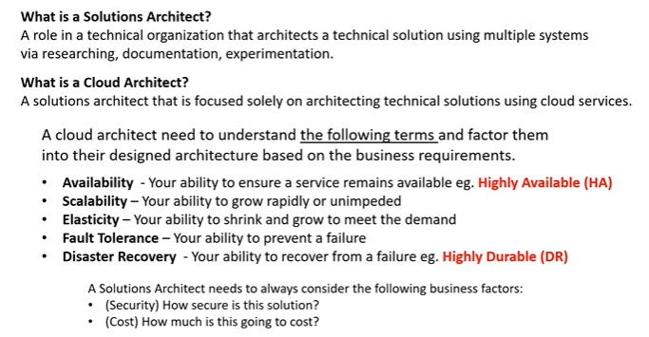

* High Availability: 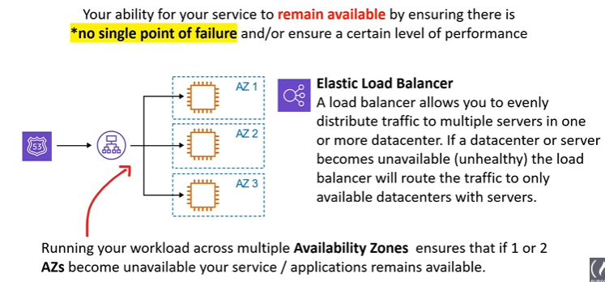
* High Scalability: 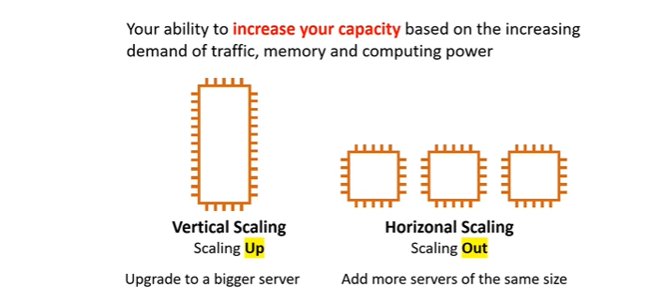
* High Elasticity: 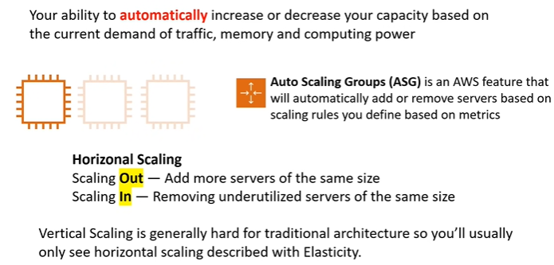
* Fault Tolerance: 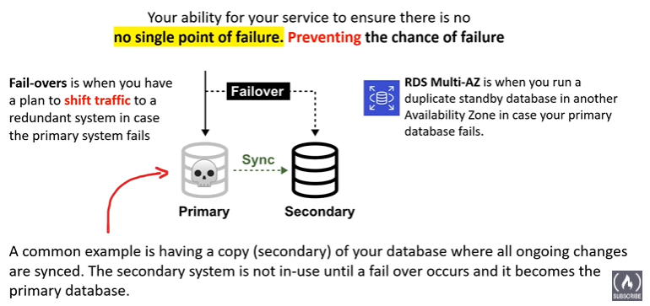
* High Durability: 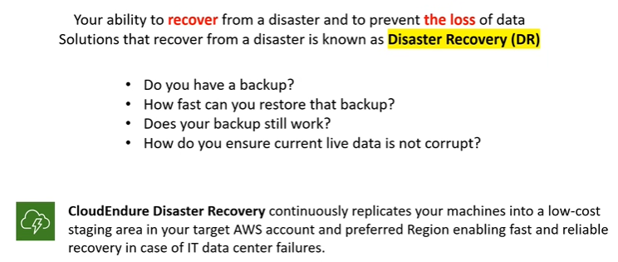

Business Continuity Plan:

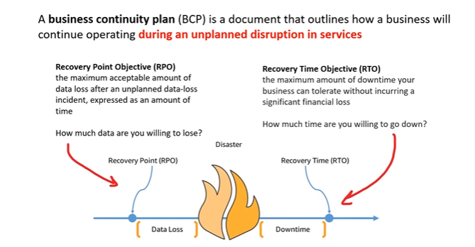

RPO: We can afford 10 mins of Data loss.

RTO: We can afford 10 mins of app being down.

Disaster Recovery Options:

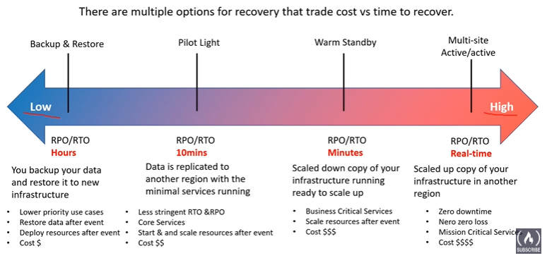

RTO Defined:

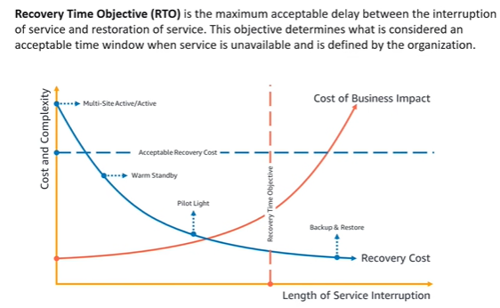

RPO Defined: 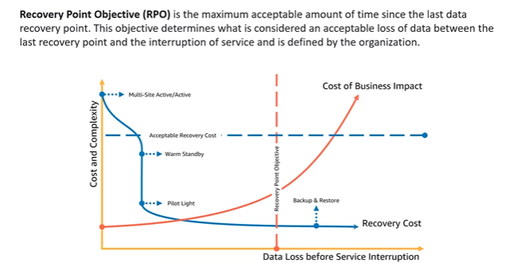

High Availability with AWS Services:

**Example:**

**AWS S3**: Amazon S3 (Simple Storage Service) in AWS is designed for high availability. It achieves this through data replication across multiple geographically dispersed Availability Zones (AZs). Each AZ is essentially a separate data center with its own power, cooling, and networking.

By default, when you store data in S3, it is automatically distributed across multiple AZs within a region. This redundancy ensures that even if one AZ becomes unavailable, your data remains accessible from other AZs.

**AWS EC2:** To ensure your applications remain accessible even during potential disruptions, AWS EC2 requires a few manual configurations to achieve high availability. This involves strategically launching multiple EC2 instances (virtual servers) and employing a Load Balancer to intelligently distribute incoming requests across them, optimizing performance and preventing downtime.

**AWS ElasticBean Stock**: AWS Elastic Beanstalk is a fully managed service that simplifies the deployment and scaling of web applications in the AWS cloud. It supports multiple programming languages and frameworks, allowing developers to focus on writing code without dealing with the underlying infrastructure. Simply upload your code, and Elastic Beanstalk handles provisioning, auto-scaling, monitoring, and more. It's a convenient option for quick and easy application deployment.

AWS Elastic Beanstalk achieves high availability through automatic scaling, load balancing, and multi-Availability Zone deployment. It dynamically adjusts the number of instances based on demand, distributes traffic evenly with a built-in load balancer, and deploys across multiple Availability Zones for fault tolerance. Continuous monitoring, rolling updates, and integration with managed databases contribute to a resilient and highly available environment.

**AWS RDS (Relational Database Service):**

AWS RDS (Relational Database Service) is a fully managed database service provided by Amazon Web Services (AWS). It simplifies the process of setting up, operating, and scaling relational databases in the cloud. With RDS, you can choose from several popular database engines, including MySQL, PostgreSQL, MariaDB, Oracle, and Microsoft SQL Server.

AWS RDS achieves high availability through Multi-AZ deployments, maintaining a standby replica in a different Availability Zone. Automatic failover, synchronous replication, and read replicas contribute to data durability and uninterrupted database availability.

AWS API:

An API allows different software applications to communicate with each other. AWS provides APIs for various services, enabling developers to interact with and manage their AWS resources programmatically.

Here are key points about AWS APIs:

**1.** **Service-specific APIs:** Each AWS service typically has its own API that allows developers to perform operations related to that service. For example, Amazon S3 (Simple Storage Service) has an API for managing storage buckets and objects.

**2.** **RESTful APIs:** Many AWS APIs follow a RESTful architecture, using HTTP methods (such as GET, POST, PUT, DELETE) to perform operations on resources.

**3. SDKs (Software Development Kits):** AWS provides SDKs in various programming languages (such as Python, Java, JavaScript, etc.), which include libraries and tools that simplify the process of integrating AWS services into applications. These SDKs often include wrappers around the underlying APIs

**4. Authentication and Authorization:** Access to AWS APIs is secured through authentication and authorization mechanisms. AWS uses various authentication methods, including API keys, AWS Identity and Access Management (IAM) roles, and temporary security credentials.

**5. AWS Management Console:** While AWS APIs are designed for programmatic access, AWS also provides a web-based management console that allows users to interact with and manage their resources through a graphical user interface (GUI).

**6. Integration and Automation:** AWS APIs are integral for automating infrastructure provisioning, managing resources, and integrating AWS services into custom applications. This is commonly done using scripts, automation tools, or serverless architectures.

**Example**: AWS S3 provides an API that allows developers to create, read, update, and delete objects in storage buckets. Using this API, you can programmatically interact with your S3 resources, whether it's uploading files, listing objects, or configuring bucket settings.

In summary, the AWS API refers to the set of interfaces provided by AWS services that enable developers to interact with and manage their cloud resources programmatically.

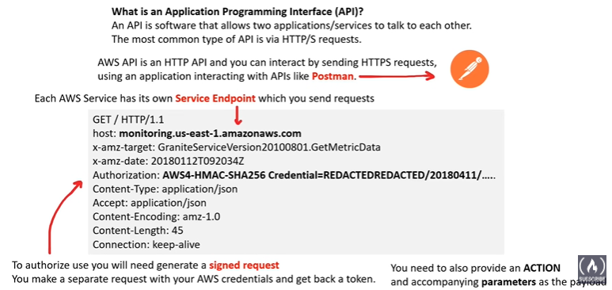

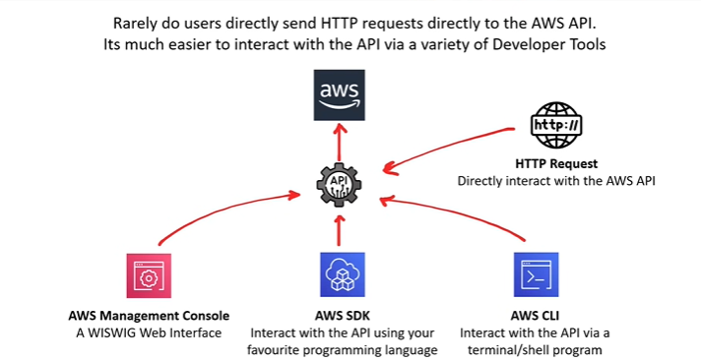

AWS Management Console: 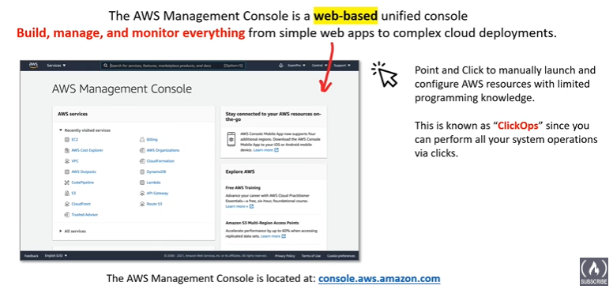

AWS Service Console:

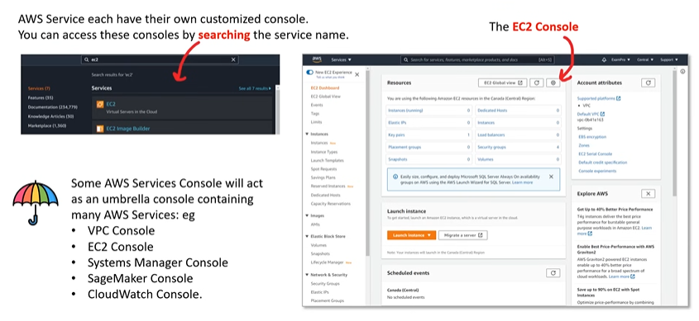

AWS Account ID:

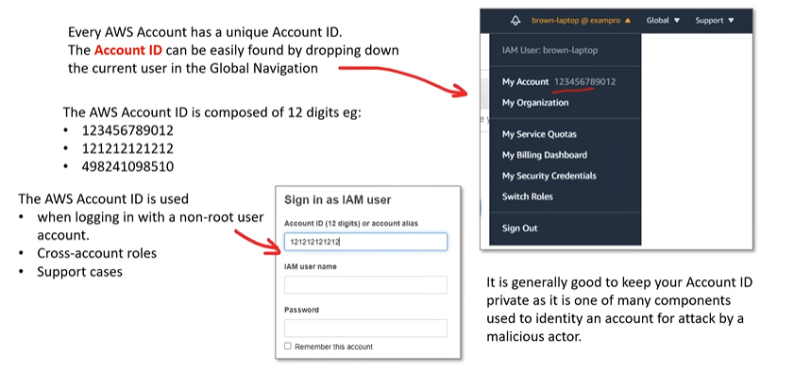

AWS Tools for PowerShell: 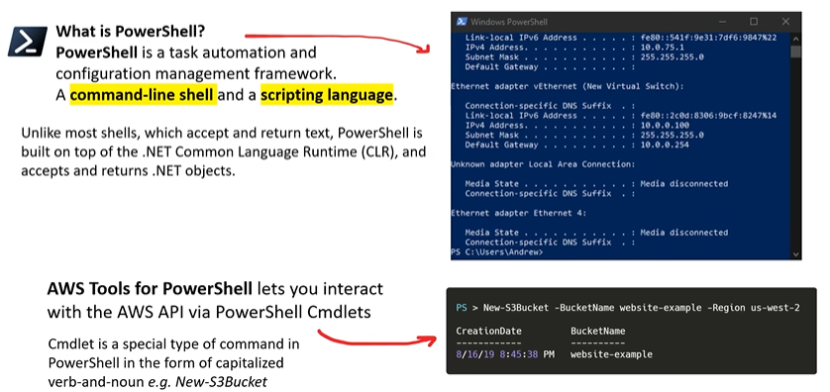

Amazon Resource Name:

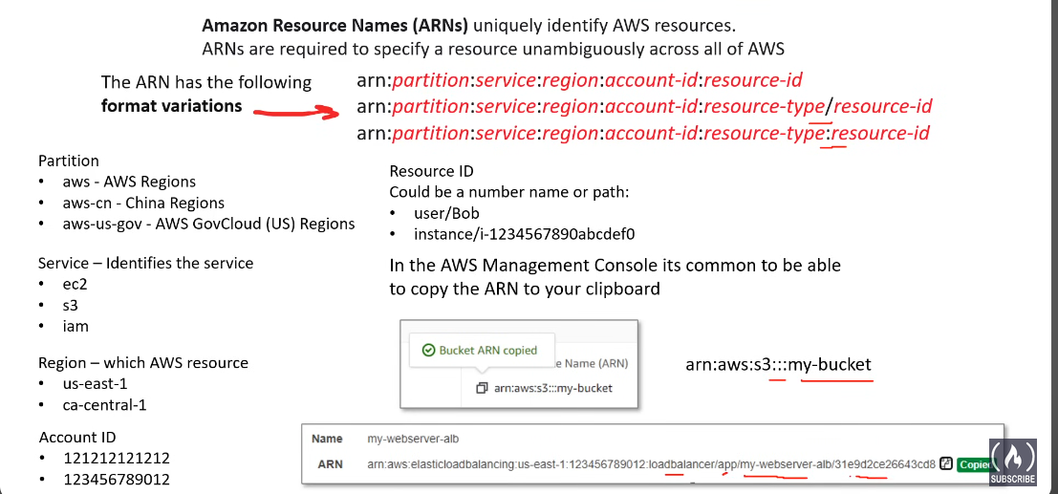

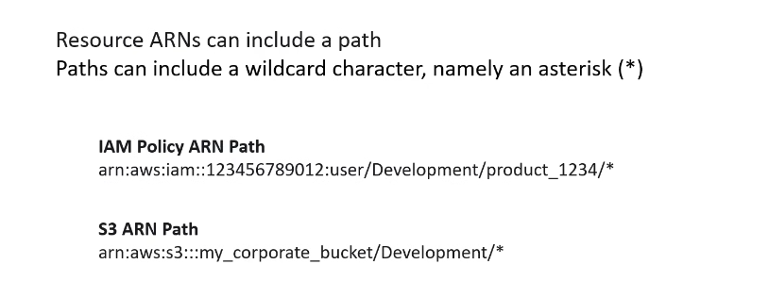

Amazon Resource Names (ARNs) are identifiers used in Amazon Web Services (AWS) to uniquely identify and reference AWS resources. ARNs play a crucial role in AWS identity and access management, as they are used to specify resources in policies, permissions, and API requests. ARNs are formatted as strings and follow a specific syntax.

The general structure of an Amazon Resource Name is as follows:

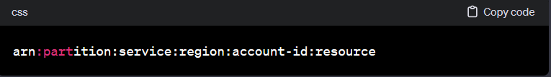

Let's break down the components of an ARN:

**1. ARN Prefix (arn):**The fixed string "arn:" at the beginning of the ARN indicates that it is an Amazon Resource Name.

**2. Partition:** The AWS partition that the resource belongs to. Common values are "aws" for the standard AWS partition and "aws-cn" for the AWS China (Beijing) partition.

**3. Service:** The AWS service that manages the resource. Examples include "s3" for Amazon S3, "ec2" for Amazon EC2, "iam" for AWS Identity and Access Management, and so on.

**4. Region:** The AWS region where the resource resides. This part is optional for some global services and required for regional services.

**5. Account ID:** The AWS account ID that owns the resource. It is a 12-digit number unique to each AWS account.

**6. Resource:** The specific identifier for the resource within the service. This part can vary widely based on the service and resource type.

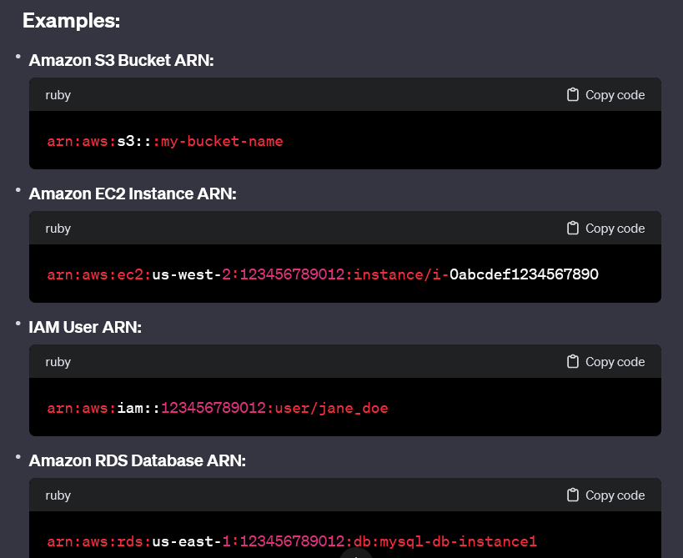

ARNs are used in various contexts, such as IAM policies, resource-based policies, and AWS CLI commands. They provide a standardized way to identify and reference AWS resources across different services and regions, allowing for granular control and management of access to these resources.

AWS CLI:

Here's a breakdown of the key differences between shell, console, terminal, and command-line:

**1. Terminal:**

* **Definition**: A software program that emulates a physical terminal, providing a text-based interface for interacting with the operating system.
* **Function**: Enables users to type commands and view output in a text-based environment.
* **Examples**: Terminal apps like Terminal on macOS, Command Prompt or PowerShell on Windows, and xterm or gnome-terminal on Linux.

**2. Console:**

* **Definition**: Historically referred to as a physical device (keyboard and monitor) for interacting with a computer. Now often used interchangeably with "terminal."
* **Function**: Provides a text-based interface for system interaction.
* **Specific Meaning:** May also refer specifically to the primary text-based interface directly connected to the machine (e.g., the text-based interface you see when booting a Linux server without a GUI).

**3. Shell:**

* **Definition**: A command-line interpreter that runs within a terminal.
* **Function**: Reads commands typed by the user, executes them, and displays the output.
* **Examples**: Bash (common on Linux), Zsh, Fish, PowerShell (Windows), and sh (Bourne shell).

**4. Command Line Interface (CLI):**

* **Definition**: A method of interacting with a computer using text-based commands, often through a terminal.
* **Function**: Provides a non-graphical way to control the system.
* **Contrast**: Opposite of a Graphical User Interface (GUI), which uses windows, icons, and menus.

**Relationships:**

* Terminals and consoles provide the environment for running shells.
* Shells interpret commands typed at the command line.
* CLI is the overall interaction paradigm using text-based commands.

**Key Points:**

* Terminals and consoles are often used interchangeably, but "console" can have a specific meaning as the primary text-based interface.
* Shells are programs that run within terminals or consoles.
* CLI is a broader term for text-based interaction with a computer.

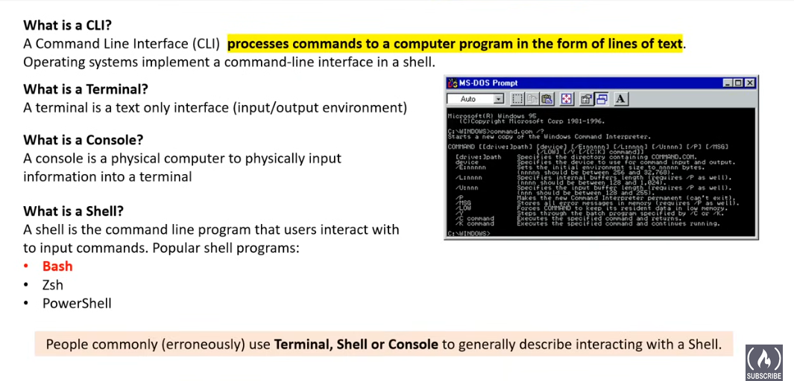

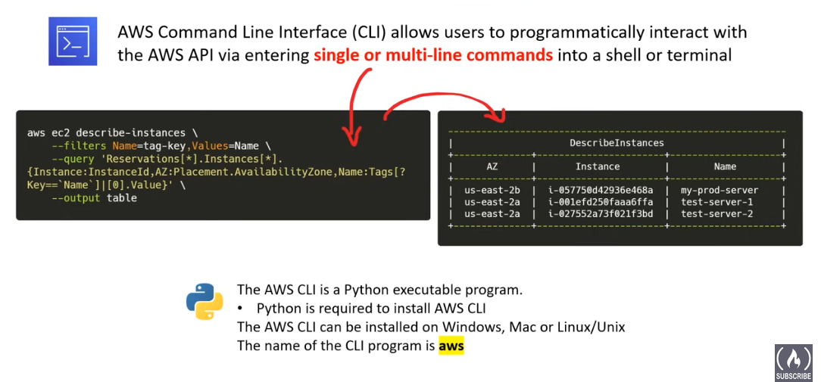

AWS SDK:

The AWS SDK (Software Development Kit) is a set of tools, libraries, and APIs (Application Programming Interfaces) provided by Amazon Web Services (AWS) to enable developers to interact with and build applications for AWS services. The SDK facilitates the integration of AWS services into various programming languages, making it easier for developers to access and use AWS resources programmatically.

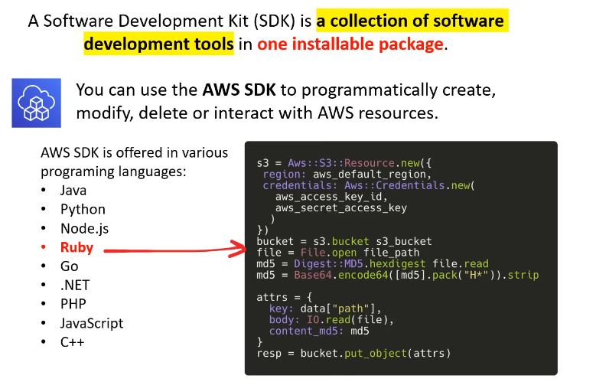

AWS Cloud Shell: 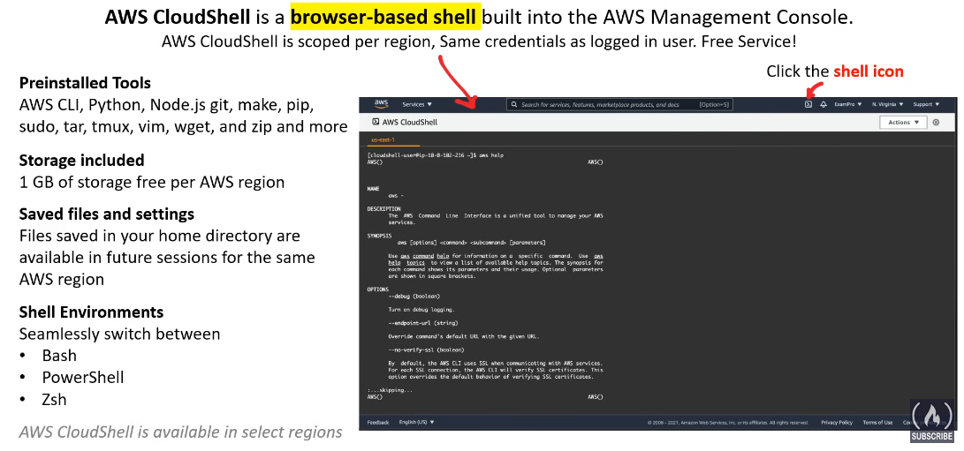

Infrastructure As Code:

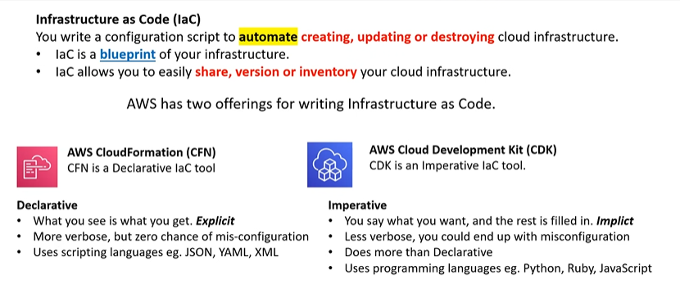

IaC is a practice that involves managing and provisioning computer data centers through machine-readable definition files, instead of using interactive configuration tools. In simpler terms, it's like writing code to automate the process of setting up and managing your servers. It's like creating a recipe for your IT environment! When it comes to IaC, there are two fundamental styles: imperative and declarative. The key difference lies in the approach to defining the desired state of infrastructure.

Imperative vs Declarative Approach of IaC:

**Declarative Approach**

* You define the desired state, and the IaC tool figures out how to achieve it. You don't need to provide step-by-step instructions.
* Focuses on "**what**" the desired infrastructure state should be.Often considered more concise and readable.
* Example tools: Terraform, **AWS CloudFormation**, Azure Resource Manager

**Imperative Approach**

* Imperative IaC, also known as procedural IaC, is like a cookbook recipe. It focuses on the "how" to achieve the desired state.
* Provides step-by-step instructions or commands to execute.
* Similar to traditional scripting or programming.
* Example tools: Ansible, Chef, Puppet, **AWS Cloud Development Kit**

**Flexibility and Complexity**

Imperative IaC can offer more flexibility as it allows you to dictate each step. However, this can result in increased complexity. Declarative IaC, while less flexible, tends to be simpler and more manageable.

**State Management**

Declarative tools maintain a state file that records the current state of infrastructure. This allows them to adjust only what's needed to reach the desired state. On the other hand, imperative tools do not maintain state, leading to possible redundancy in operations.

**Use Cases**

Imperative IaC, with its detailed instructions, is often better suited for sequential tasks such as software deployments. Declarative IaC shines in defining and managing entire systems or environments due to its emphasis on the end state.

AWS CloudFormation:

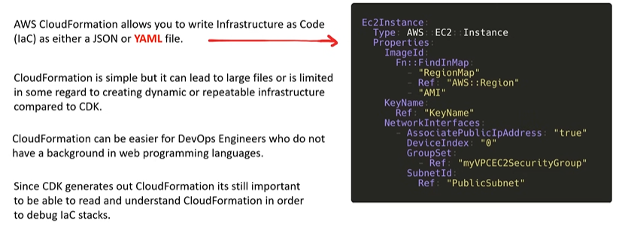

AWS Cloud Development Kit:

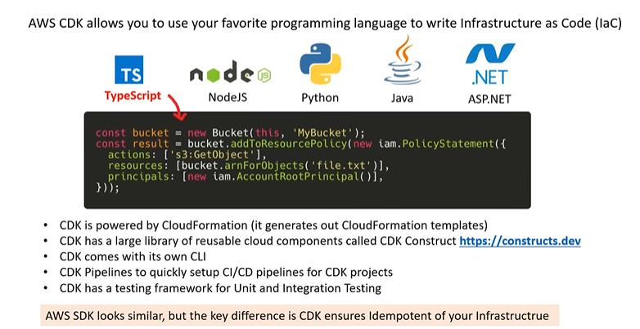

What is the difference between AWS CDK and SDK?

AWS CDK is an infrastructure-as-code tool that allows developers to define AWS resources in code. On the other hand, AWS SDK, or Software Development Kit, provides a set of tools for developers to interact with AWS services, such as creating API calls and Lambda functions.

AWS Toolkit for VS Code:

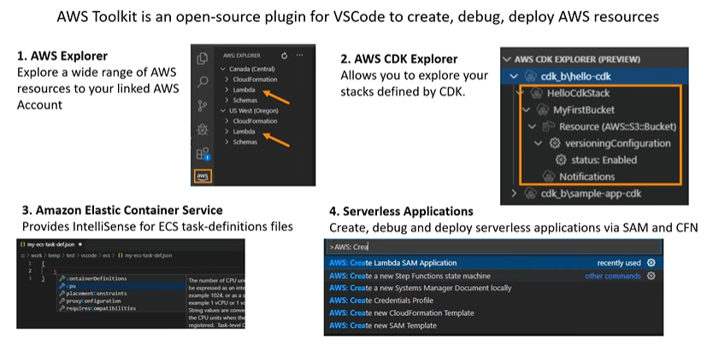

AWS Access Keys:

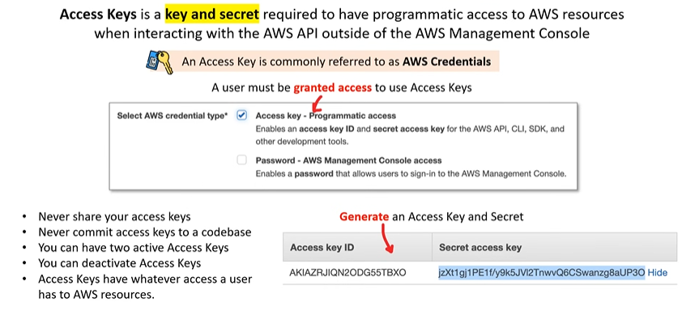 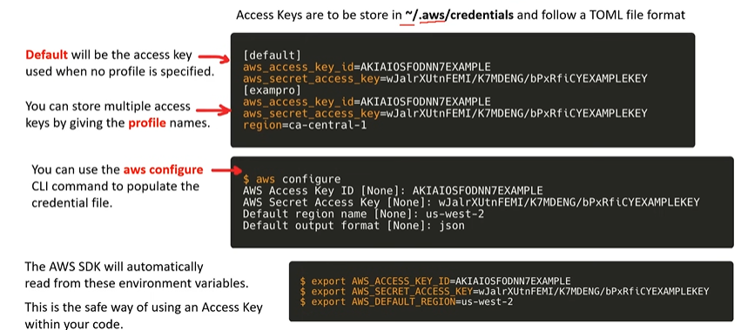

AWS Documentation:

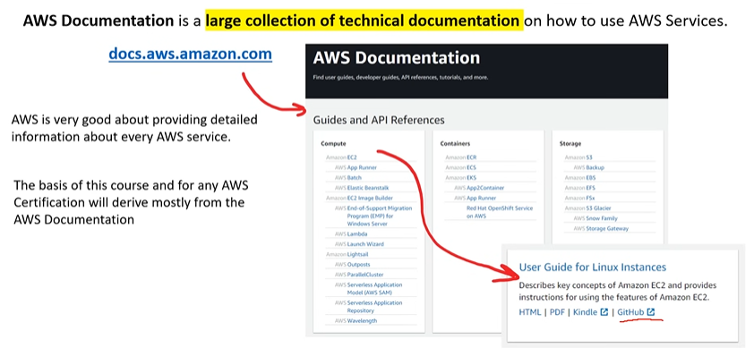

Introduction to Shared Responsibility Model:

The AWS Shared Responsibility Model is a framework that defines the security responsibilities of both AWS and its customers. It's a visual representation of where each party is responsible for securing the cloud environment.

**AWS is responsible** for the security of the **cloud infrastructure**. This includes the physical hardware, software, and networking that make up the AWS platform. AWS takes care of securing the underlying infrastructure, so you don't have to worry about patching servers or maintaining complex security controls.

**Customers are responsible** for the security of their **cloud workloads**. This includes your applications, data, and the configurations of your AWS resources. You need to implement security best practices within your workloads to protect them from unauthorized access, data breaches, and other threats.